Obed Wild and Scenic River Rock Climbing Survey Results

Charles B. Sims and Donald G. Hodges

Final Report to:
National Park Service



June 1, 2004

- Obed WSR Rock Climbing Survey
  - Introduction

Research Methods

Summary of Results

Management Implications
- Overall Results

Perceptions and Preferences of Rock Climbers at the Obed WSR
    - Important factors in choosing a climbing site
Graph A1.1: Importance of climb characteristics
Graph A1.2: Importance of climbing type availability
Graph A1.3: Importance of site characteristics
    - Evaluations of Obed WSR rock climbing sites
Graph A2.1: Lilly Boulder Field
Graph A2.2: Lilly Bluff
Graph A2.3: North Clear Creek
Graph A2.4: South Clear Creek
Graph A2.5: Obed
Graph A2.6: Y-12
Graph A2.7: Little Clear Creek
Graph A2.8: Overall
    - Perceptions of management issues at the Obed WSR
Table A3.1: Average perception of management issues
Graph A3.2: Percentage of respondents that indicated problem
    - Motivations for rock climbing at the Obed WSR
Table A4.1: Average motivations for rock climbing

Characteristics of Rock Climbers at the Obed WSR
    - Demographics of rock climbers at the Obed WSR
Graph B1.1: Marital status
Graph B1.2: Gender
Graph B1.3: Age
Graph B1.4: Income
Graph B1.5: Education
Graph B1.6: Member of rock climbing club or organization
    - Experience and skill level of rock climbers at the Obed WSR
Graph B2.1: Rock climbing experience
Graph B2.2: Experience at each climbing site
Graph B2.3: Self-perceived skill level

Aspects of Climbing Use and Trip Characteristics
    - Type and amount of climbing use
Graph C1.1: Type of climbing
Graph C1.2: Annual amount of climbing per person
Graph C1.3: Annual amount of climbing at Obed WSR per person
Graph C1.4: Percentage of total climbing that occurs at Obed WSR
Graph C1.5: Comparison of total climbing user days by year
Table C1.6: Total annual climbing user days at Obed WSR by site
Graph C1.7: Climbing user days at Obed WSR
Graph C1.8: Obed WSR climbing site visitation by season
Graph C1.9: Total visitation by site
Graph C1.10: Percent of total visitation by site
    - Trip characteristics
Graph C2.1: Average length of multi-day trip
Graph C2.2: Average length of day trip
Graph C2.3: Day use vs. multi-day use
Graph C2.4: Distanced traveled to climb at the Obed WSR
Graph C2.5: Group size

Trip Expenditures and Economic Impact
    - Trip expenditures
Table D1.1: Average trip expenditures by category
Graph D1.2: Percentage of trip expenditures by category
Graph D1.3: Percentage of trip expenditures by location
    - Economic impact
Table D2.1: Direct economic impact by month

Travel Cost Model
    - Poisson regression variables
Table E1.1: Definition of Poisson regression variables
Table E1.2: Mean and standard deviation of regression variables
    - Results of Poisson regression
Table E2.1: Poisson regression results
Table E2.2: Elasticities and marginal effects
    - Value of rock climbing at the Obed WSR
Table E3.1: Consumer surplus for rock climbing at the Obed WSR

Appendices

Appendix 1 (On-site interview)

Appendix 2 (Mail survey)

Appendix 3 (Comments from survey respondents)
D. Appendix 4 (Climbing Site Map)

Literature Cited

I. Obed WSR Rock Climbing Survey

Introduction

Recreational rock climbing has experienced a dramatic growth in popularity in recent years. Based on results from the National Survey of Recreation and the Environment (NSRE) conducted by the US Forest Service, annual rock climbing and mountain climbing participation in 1994-1995 was estimated to be 7 to 9.5 million respectively (Cordell et al. 1997). An additional study based on a national telephone survey conducted by the Institute for Public Policy (IPP) at the University of New Mexico performed a mere 4 years later found that the potential number of rock climbers in the United States may be as high as 21 million.
Demand for areas which provide for such recreation along with the growing popularity of rock climbing recreation in the United States. This growth has occurred for a number of reasons which include but are not limited to: an ever increasing population, increases in amounts of free time and expendable income, increase in popularity of “extreme” activities, and accessibility of information and instruction related to rock climbing. The nature of rock climbing limits the available land base even further. Cliffs and rock walls located on private property are often deemed off-limits by landowners who fear liability if rock climbers are injured on their property. The management of rock climbing on public lands has caused a great deal of national debate and controversy as the US Forest Service (USFS) under the U.S. Department of Agriculture (USDA), announced intent to implement a policy restricting the way climbers could recreate in wilderness areas (USDA 1998). In addition, many agencies that manage public lands that experience a high volume of rock climbing use, have begun to draft climbing management plans limiting recreational rock climbing activities.
For the Obed Wild and Scenic River (WSR), rock climbing recreation management surfaced as a high priority issue in the late 1990s. While climbing in the area can be traced back as far as the 1970s much of the development of the area did not take place until the early 90s (Watford 1999). As climbing at the Obed WSR became more popular and more climbers began to visit the area, many believed that official management action must be taken to protect the recreational experience of climbers and other visitors as well as protecting the natural characteristics of the area. Until this point much of the climbing had taken place inconspicuously and therefore warranted no management by park officials. In August 2000, the NPS placed a moratorium on establishing fixed anchors at Obed WSR until park managers could gain an understanding of the impacts of climbing on natural and cultural resources and prepare a plan to manage future climbing activities (National Park Service 2002). In February 2002 a draft climbing management plan was submitted for public revue. That management plan was finalized in July 2002.
The climbing management plan places a moratorium on developing new routes and limits climbing to six areas designated as either a bouldering area or a rock climbing zone. The plan also outlines issues related to trails, parking, access, equipment usage, and route “top-outs” which is the act of climbing a route all the way to the cliff top, which can damage rare cliff-dwelling species of vegetation. The management plan also called for a number of research studies in order to support the plan. One of the studies outlined in the management plan is researching the rock climbing use levels (National Park Service 2002). The University of Tennessee was commissioned in 2002 to conduct a survey to measure rock climbing use levels, user demographics, opinions on management, trip characteristics as well as modeling trip-taking behavior.
The results of the survey are presented in this report. The results are organized into five sections that enable pertinent information to be found quickly. The first section describes the perceptions and preferences of rock climbers who visit the Obed WSR including opinions on current management. The second section describes various characteristics of those who participate in rock climbing at the Obed WSR including personal demographics and experience levels. The third section identifies the type of climbing use and other trip characteristics. The fourth section focuses on trip expenditures and direct economic impact. The fifth and final section deals with the results and interpretation of the travel cost model. These five sections are followed by a set of appendices which include examples of the on-site interview and the mail survey, as well as a catalog of comments from survey respondents.

- Research Methods
1. Survey Design
Information gathering techniques for this study included a combination of on-site and mail surveys. To ensure that the questions elicit answers to the intended purpose, the interview and survey instruments underwent an extensive pre-testing procedure. Initial copies of the interview and survey instruments were forwarded to local climbers that frequent the Obed to secure critiques of question format and structure as well as suggestions for alternative means of obtaining the required data. The survey instruments were revised based on the reviews and administered to rock climbing organizations in the study area. After the organization members completed the surveys, they were interviewed to ascertain how they interpreted each question and how the questions may be reworded to elicit the desired information.
2. Sampling Methodology
Rock climbing surveys and interviews occurred over a 12-month period and were disaggregated into 7 recreation sites that were divided into 3 survey units. The recreation sites in this area include private lands, Nature Conservancy holdings, and National Park Service administered lands. The research team contacted visitors at the climbing access points within the Obed WSR and administered a short (< 2 minutes) interview to identify where they were climbing, the duration of their visit, and their place of residence. At the end of the on-site interview each climber was asked if they would complete a more detailed survey and return the completed survey via mail. If they agreed to complete the survey, they were given a packet with a cover letter reiterating the purpose of the study, a survey form, and a return envelope with postage attached. Three hundred and two interviews of rock climbers were conducted and 292 agreed to complete the mail survey. Of those 292, 140 returned the survey for a response rate of 48%.
The on-site interviews were conducted on 96 days over a 12-month period beginning November 1, 2002 and ending October 31, 2003. The 96 days represents approximately 25 percent of the days during the survey period. The interview days were spread uniformly over the 12 months (8 days per month) among weekdays (Monday – Thursday) and weekends (Friday – Sunday). Although the majority of use during the fall and winter months is likely to occur on weekends, sampling throughout the month will allow for more accurate use estimates on a daily basis. Because the winter and spring months in 2003 experienced above average rainfall, use estimates for these months were likely lower than average. Therefore, use counts were continued from January through April 2004. However, weather patterns for these months were much drier than normal resulting in use estimates that are most likely greater than normal. Total use estimates based on 2003 and 2004 data are included to provide an upper and lower bound on use estimates for a typical year.
Interviewing was allocated proportionally among six climbing areas identified within the Obed WSR based on the use patterns provided by the Obed rangers. Interviews for users of Lilly Boulders were conducted each day that the research team was at the Obed WSR. One member of the research team walking through the boulder field for approximately two hours and contacting the boulderers on-site accomplished this. Three main access points were identified within the area for the remaining six climbing sites: Lilly Bluff Parking Area (LB), Lilly Bridge (LBR), and a parking area located on private land that provides access to climbing areas owned by The Nature Conservancy (TNC). Two climbing areas are accessed by the Lilly Bluff Parking Area (Obed and Y-12), two at Lilly Bridge (Lilly Bluff and Little Clear Creek), and two by the TNC area (North and South Clear Creek). Over the 12-month study period, 13 days were allocated to interviewing at the Lilly Bluff Parking area, 28 at Lilly Bridge, and 55 at the TNC area.
The survey process followed procedures similar to those outlined by Dillman (2000). All users who agreed to complete the mail survey received a postcard reminder one week after the on-site interview. Two weeks after the postcard reminder, all non-respondents received a second copy of the survey and a cover letter urging them to complete the survey and stressing the importance of their response. Three weeks after the second copy mailing, a sample of the remaining non-respondents was contacted by phone to determine why they did not respond and check for non-response bias.
3. Travel Cost Model
The travel cost method is used to estimate the value of recreational benefits generated by ecosystems. It assumes that the value of the site or its recreational services is reflected in how much people are willing to pay to get there. It is referred to as a “revealed preference” method, because it uses actual behavior and choices to infer values. Thus, peoples’ preferences are revealed by their choices. The travel cost model was used in this study for two reasons. First, it allows trip-taking behavior to be modeled. By modeling trip-taking behavior, land managers can determine the effects of management actions on the number of trips visitors take to the site. Second, the travel cost method allows for the estimation of consumer surplus. Consumer surplus is measured as the difference between the demand for the good and the amount paid. In other words, consumer surplus is a monetary representation of the value individuals receive.
The basic premise of the travel cost method is that the time and travel cost expenses that people incur to visit a site represent the “price” of access to the site. Thus, peoples’ willingness to pay to visit the site can be estimated based on the number of trips that people make at different travel costs. This is analogous to estimating peoples’ willingness to pay for a marketed good based on the quantity demanded at different prices. The assumption is made that, as the number of trips an individual takes increases, the amount of travel costs incurred will decrease. This assumption is critical in that it allows a demand curve to be estimated based on travel costs and number of trips. Once the demand curve is estimated, calculating the net willingness to pay or consumer surplus simply entails adding up the areas below the demand curve and above the price for the various users of the site (Rosenthal et al. 1984).
In order for a demand curve to be estimated, the price of the good demanded (in this case number of rock climbing trips) must be determined. The travel cost model assumes that the price of a rock climbing trip is representative of the costs incurred in order to recreate at that site (i.e. travel cost). However, several assumptions must be met in order for travel costs to represent the price of a rock climbing trip (Freeman 1999). The first of these is that the visitor is on a single-destination, single-purpose trip. For our purposes this would be a trip in which the only destination was the Obed WSR for the sole purpose of rock climbing. For this paper, this assumption will be addressed through survey design. Individuals indicating a multipurpose trip were asked to report the number of days spent for rock climbing in relation to the total number of days for the trip. A percentage of days spent for rock climbing at the Obed WSR was calculated and this percentage was applied to total travel cost estimates for the trip. This assumes that travel costs per day are constant throughout the trip. We feel that this assumption is satisfied in this case because most multi-destination trips were trips to the Obed and other rock climbing areas. Travel costs to one rock climbing area should be reasonably similar to travel costs to other rock climbing areas.
Another assumption is that the opportunity cost of travel time to the Obed WSR for the purpose of rock climbing is some how related to the individual’s wage rate. As is well known (Cesario 1976; McConnell and Strand 1981), travel time as well as travel cost should be included in a travel cost model. Some researchers treat travel time as an endogenous variable (Shaw and Ozog 1999; Desvouges and Waters 1995). Others have included a proportion of the wage rate as an additional factor in the travel cost measurement (Randall 1994; Englin and Shonkwiler 1995). When calculating consumer surplus, only actual monetary expenditures incurred are to be used. The inclusion of travel time as an additional factor in the travel cost variable will bias welfare estimates unless this aspect of the travel cost variable is removed before calculating welfare measures. In order to remove this bias, the cost of travel time was included as an endogenous variable represented as a function of the miles traveled from origin to the Obed WSR for rock climbing.
The monetary cost of a trip to the Obed WSR for rock climbing is composed of two parts: the admission fee f and the monetary cost of travel including the opportunity cost of travel time. Since the Obed WSR charges no admission fee to the area, total cost is comprised of the monetary cost of travel (Freeman 1999). The costs of travel were disaggregated into five parts: lodging, food and beverage, transportation, activities and entertainment, and other expenses. Since rock climbing requires substantial equipment purchases to begin participation (high fixed costs) and it is reasonable to believe that these purchases may play a significant part in travel choice behavior, additional rock climbing expenditures are needed to supplement the marginal costs experienced by rock climbers on each trip. Based on previous research we would expect the coefficient on travel costs to be negative, inferring a negative relationship between travel cost and the number of trips (e.g., Loomis and Walsh 1997; Fix and Loomis 1997).
In a traditional single site travel cost model, the value an individual places on that particular site is significantly affected by neighboring sites that may provide similar recreational experiences. These substitution effects are critical for precise model specification, as their exclusion may overstate the estimates of consumer surplus (Rosenthal 1987). Possible substitute sites for rock climbing at the Obed WSR were identified through focus groups composed of Obed WSR rock climbers. When asked what other rock climbing areas they had visited in the past 12 months, popular rock climbing sites in Tennessee, Alabama, Georgia, North Carolina, Kentucky, and West Virginia were named. Effects of these substitute sites were incorporated into the model by calculating the average travel costs to these sites as a function of miles traveled.
Because individuals make choices about recreation based on the quality of recreation at a particular site, previous literature has included various quality variables with great success (Morey 1981; Smith et al. 1983a; Caulkins et al. 1986; McConnell 1986). While site characteristics are important in modeling the demand for a recreational area, existing travel cost literature provides little insight into selecting appropriate site characteristics for rock climbing areas. In order to determine which site attributes are important, survey respondents were asked to rank site attributes on their importance in affecting site choice. Survey respondents indicated that the five most important site attributes in choosing a climbing site were rock quality, number of climbs, availability of sport climbing, availability of good protection, and difficulty of climbs. Since measures of rock quality, availability of sport climbing, and availability of good protection do not change across the survey sample, an appropriate site quality characteristic is the number of climbing routes available to the climber, where the limiting factor is the individual’s technical ability (Shaw and Jakus 1996). This site characteristic is similar to the ability-specific characteristic Morey (1985) constructs for skiers and ski area choice. We hypothesized that as the number of climbs in the climber’s ability range increases, more rock climbing trips to the OWSR are likely. Therefore, it was hypothesized that this variable should have a positive coefficient.
Poisson regression techniques were used to model the demand for rock climbing trips at the Obed WSR. The Poisson distribution is far more consistent with a data generating process producing only a few trips per visitor. In addition, the Poisson model is one in which the maximum likelihood estimator (MLE) is robust to certain misspecifications of the model, such as the failure to incorporate latent heterogeneity in the mean. In order to correct for this misspecification, a robust covariance matrix was used. The model estimated has a Poisson distribution with the general specification being:

Y_{i} = exp (PRICES_{i}, QUALITY_{i}, DEMOGRAPHICS_{i}, error term) (1)

The model estimated also corrects for endogenous stratification, which occurs with onsite sampling. With on-site sampling, the likelihood of a person being sampled is related to the frequency of their visits. In the Poisson specification, subtracting one from the reported number of trips adjusts the annual number of trips downward to reflect the fact that those who take a higher number of annual trips are more likely to be sampled (Englin and Shonkwiler 1995). The specific model specification is as follows:

lnTRIPS=B₀ - B₁*TC - B₂*SKILL + B₃*RCGRP + B₄*INC + B₅*MILES +
B₆*BLDR + B₇*DAY + B₈*CLIMBS + B₉*SUB (2)

where TRIPS is the estimated number of rock climbing trips taken; TC is travel costs for a rock climbing trip to the Obed WSR; SKILL is the individual’s skill level based on a sport climbing grade; RCGRP is a dummy variable to represent membership in a rock climbing club or group (1=Yes, 0=No); INC is the individual’s annual income before taxes; MILES is the miles traveled to the Obed WSR; BLDR is a dummy variable to determine whether the individual is a boulderer (1=Yes, 0=No); DAY represents whether the trip taken was a day trip (1=Yes, 0=No); CLIMBS represents the number of climbs in the climber’s ability range; and SUB is the travel cost measured in miles to all relevant substitute sites.
Basic demographic variables (INC, SKILL, RCGRP, BLDR) were included in the model to coincide with previous travel cost studies (Morey 1981; Samples and Bishop 1985; Shaw and Jakus 1996; Grijalva et al. 2002). These variables are consistently found in various travel cost models. Because rock climbing groups and organizations sponsor numerous riding events annually, participation in such groups should reasonably lead to more rock climbing trips taken. In order to include this effect (which is expected to be positive) in trip taking behavior a variable was added to identify participation in rock climbing groups.
Survey data indicated that the majority of climbing taking place at the Obed WSR was sport climbing followed by bouldering. A dummy variable (BLDR) was included to determine differences in trip taking behavior between these two user groups. In addition, MILES and DAY were included to determine what effect these trip characteristics may have on the number of trips taken. We anticipate that as the number of miles traveled increases the number of trips taken will decrease.
The value of access equals the area under the expected demand curve. For the exponential demand function, the choke price (C*) is infinite. Using a simple demand specification: x=e^β₀+β₁C where C is the travel cost, and β₀ can be a constant or a function of covariates other than own price. For any finite C, x= e^β₀+β₁C>0. Defining C⁰ as the current travel cost, consumer surplus for access is

WTP = [(e^β₀+β₁C)/β₁] = -x/ β₁ (3)

where x represents the number of trips taken by the individual and β₁ is the parameter estimate for travel costs. In the Poisson expression for sample mean WTP, one can use the mean of observed trips or mean of the expected trips because the Poisson model has the property that it is mean fitting (Haab and McConnell 2002). The mean of observed trips was used for calculations in this study. Consumer surplus estimates generated through this procedure provide an estimate of the individual value of rock climbing recreation at the Obed WSR.

- Summary of Results
Section A: Perceptions and Preferences of Rock Climbers at the Obed WSR
  - Rock quality, number of routes, the availability of sport climbing, the difficulty of routes, and the availability of good climbing protection were all important to very important factors in the decision of which climbing site to visit.

  - Walking distance from the car and the availability of traditional climbing and bouldering were considered the least important factors in the decision of which climbing site to visit.

  - Lilly Boulder Field was rated well for walking distance to site and badly for availability of information about site.

  - Lilly Bluff was rated well for sport climbing but poorly for other types of climbing (trad, bouldering) and solitude.

  - North Clear Creek was rated well for scenery and bad for solitude.

  - South Clear Creek was rated well for sport climbing availability and rock quality but badly in terms of the availability of other types of climbing.

  - Obed and Y-12 were rated well for sport climbing and scenery but poor for walking distance.

  - Little Clear Creek was rated well for sport climbing and scenery but poor for other types of climbing.

  - Overall, all sites were considered desirable with South Clear Creek being the most desirable climbing site.

  - No visitor issue was considered a serious problem.

  - Lack of suitable campsites was considered a problem for 69% of those surveyed.

  - Impacts to soil and vegetation were considered a problem for 71% of those surveyed.

  - Litter was considered a problem for 67% of those surveyed.

  - Poor communication of rules and regulations was considered a problem by 57% of those surveyed.

  - Lack of designated routes was considered a problem for only 20% of those surveyed

  - The most popular reasons for rock climbing at the Obed WSR were to “do something challenging”, “develop and test my skills and abilities”, and “enjoy natural scenery”.

  - The least popular reason for rock climbing at the Obed WSR was “to be alone”.

Section B: Characteristics of Rock Climbers at the Obed WSR
- Over 76% of those surveyed indicated they were single.
- 70% of those surveyed were male.
- Over 66% of those surveyed were between the ages of 20 and 30 years old.

- Nearly 47% of those surveyed earned less than $10,000 a year with the average annual income between $25,000 and $35,000.

- Over 36% of those surveyed were college graduates and 20% had earned a graduate degree.

- Over 45% indicated that they belonged to a rock climbing club or organization. Of those 75% indicated that they paid yearly dues, membership fees, or had made a contribution to that group with an average amount paid of $60 annually.

- Over 46% of those surveyed had been climbing for 1 to 5 years and more than 33% had been climbing longer than 5 years.

- The climbing areas that climbers had the least experience with were Little Clear Creek and Y-12 while indicating a great deal of experience at South Clear Creek and Lilly Bluff

- Over half (51%) noted that his/her skill level lies somewhere between 5.10a and 5.11d, based on the U.S. sport climbing rating system.

Section C: Aspects of Climbing Use and Trip Characteristics
- Over 82% of the climbing taking place at the Obed WSR is sport climbing with only 3% being trad climbing. Bouldering is responsible for nearly 28% of the climbing at the Obed WSR.

- Over 63% of those surveyed indicated they climbed more than 50 days per year.

- Nearly 27% of those surveyed indicated they climbed more than 50 days a year at the Obed WSR.

- Over 43% of those surveyed indicated that over 75% of their annual climbing takes place at the Obed WSR.

- On average trips to the Obed WSR constituted approximately 56% of the total number of rock climbing trips taken per year.

- Survey respondents indicated they take an average of 32 rock climbing trips to the Obed WSR annually.

- The times of greatest climbing use at the Obed WSR are during the spring and fall months with climbing dropping off considerably in the middle of the summer and winter.

- South Clear Creek appears to be the most heavily used site with Lilly Bluff being the second most visited site.

- As the temperature rises climbers tend to visit Lilly Bluff more often; likely because Lilly Bluff is in the shade and South Clear Creek is in full sun.

- Because the winter and spring of 2003 experienced above average precipitation the count estimates for these months were much lower than normal. Therefore, count estimates were also performed from January to April of 2004. Count estimates were greater in 2004 for every month with a considerable increase in February, March, and April.

- Total climbing user days were calculated for each month and summed over the course of the year to reveal that the Obed WSR is responsible for over 2500 rock climber user days per year.

- When revised count estimates collected from January through April 2004 were used the total rock climber user days at the Obed WSR increased to over 3500.

- Over 45% of those surveyed indicated their day trip lasted from 4 to 6 hours with 6 hours being the average length of a day trip.

- For multi-day trips, nearly 70% indicated their trip was 2 days long with the average length of a multi-day trip being 2.8 days.

- The majority of climbing trips at the Obed WSR were day trips with only 25% indicating they were on a multi-day trip.

- Over 62% of those surveyed traveled less than 50 miles to rock climb at the Obed WSR; however, over 7% traveled more than 200 miles with the average distance traveled being over 90 miles.

- Visitors were noted from as far away as Colorado, California, Oregon, and Canada.

- The average climbing group consisted of 2.8 climbers.

Section D: Trip Expenditures and Economic Impact
- The largest average trip expenditure categories were the food and beverage and transportation categories with the total average trip expenditures estimated at $46.20.

- Lodging expenses were significantly smaller due to the large proportion of respondents that camped on public and private property.

- Over 51% of trip expenditures occurred while traveling to and from the Obed WSR with only 38% occurring in Morgan County.

- Rock climbing at the Obed WSR is responsible for an average of over $146,000 in direct economic impact annually based on an average of 2003 and 2004 use estimates.

- The average depreciated equipment costs were $13.96 per person per trip.

Section E: Travel Cost Model
- The price variable, TC, was negative and significant at the 1% level as expected by travel cost theory.

- A 10% rise in travel costs would decrease the number of climbing trips taken to the Obed WSR by 3.5%.

- The Obed WSR is considered by users to have substitutes as evidenced by a positive and highly significant substitute price variable.

- The income variable, INC, was positive and significant at the 5% level.

- A 10% increase in income would increase rock climbing trips taken to the Obed WSR by 1.7%.

- Results also indicate a positive relationship between day use and number of trips.

- The insignificance of the quality variable, CLIMBS, reveals that an increase in the number of climbing routes available would not influence the number of trips that current users take.

- The value per-trip of rock climbing at the Obed WSR was estimated at $170.62.

- The value per-day of rock climbing at the Obed WSR was estimated at $113.75.

- Individual consumer surplus per season was found to be $6,903.58.

- Annual consumer surplus experienced by rock climbing visitors to the Obed WSR is estimated at nearly $286,000 based on the 2003 estimate of 2513 user days per year.

- Annual consumer surplus increases to over $399,000 based on the 2004 estimate of 3515 user days per year.

- Management Implications
- Lack of suitable campsites was considered a problem by 69% of those surveyed. Many of these climbers likely traveled to Rock Creek Campground and Frozen Head State Park, which are over 20 miles from the climbing areas. Many of these climbers were also unfamiliar with backcountry camping in the area. Because many National Park Service units regulate backcountry camping, many climbers assume that backcountry camping is not allowed. Clarification of backcountry camping rules could alleviate part of the camping problem. In addition, many local climbers have been camping on the private property – primarily that owned by Del Scruggs. Mr. Scruggs encourages camping on his property and could be an alternative to those who seek less primitive camping options. By working with private landowners such as Mr. Scruggs, the Park Service could expand opportunities without building an additional campground on public land. The primary activities would involve informing landowners adjacent to the Obed of the economic opportunities of and potential remedies for liability from providing primitive campground facilities, as well as publicizing the availability of such facilities to Obed users.

- The Obed Climbing Management Plan currently prohibits climbers from establishing new climbing routes until research is conducted identifying the need for and impact from new climbing routes. Crowds and lack of designated routes were not considered problems for those surveyed. Additionally, results from the regression analysis reveals that more climbing routes would not increase the number of climbing trips taken. However, the addition of new climbing routes may attract new climbers to the area. A comparison of the difficulty of climbs available and the type of climbers visiting the area illustrates that the climbs available are skewed toward the 5.10 to 5.11 skill level. While 14% of climbers visiting the Obed are in the 5.8 to 5.9 skill level, only 8% of the bolted climbs at the Obed are in that skill level. Climbers who are capable of placing bolts are usually more technical climbers; therefore, leading to more technical routes being bolted. While a lack of designated routes does not appear to be a problem at the Obed, the difficulty of the current routes does not correspond to the distribution of climbing abilities of visitors to the Obed. Therefore, new routes in the beginner skill range should be added at the Obed as long as these routes do not compromise the integrity of existing routes.

Skill level | % of total bolted climbs at Obed | % of climbers visiting the Obed
5.6 to 5.7 | 3% | 6%
5.8 to 5.9 | 8% | 14%
5.10 to 5.11 | 61% | 51%
5.12 to 5.13 | 28% | 29%

- When asked to rate the importance of specific site factors in their choice of climbing sites to visit, survey respondents indicated that walking distance from the car to the climbing site was an unimportant factor. However, many survey participants indicated a need for more convenient access to the Obed and Y-12 climbing areas. While the Park Service does provide access to these areas via the Point Trail, access through private property allows climbers to park closer to these climbing areas. Providing more convenient access to these climbing areas could reduce the practice of accessing these areas from private property and avoid potential conflicts between climbers, the National Park Service and local property owners. In addition, the area known as the Obed Wall was actually ranked a more desirable climbing area than Lilly Bluff but was used considerably less than Lilly Bluff likely due to the access issues at Obed Wall. Improving access at Obed Wall could alleviate potential crowding issues at the more heavily used South Clear Creek and Lilly Bluff sites.

- Litter and impacts to soil and vegetation were considered a problem by more than 67 percent of those surveyed. Many climbers felt that litter was more of a problem at the heavily used overlook parking area and Lilly Bridge and felt that the problem stems predominantly from non-climbers. Whether this is the case or not, the climbing community has demonstrated a willingness to deal with this issue through clean up and maintenance days. A close relationship between the National Park Service and climbing organizations such as the Access Fund will ensure that the Park officials have an ally in their efforts to preserve the natural integrity of the park. Perhaps more could be done to educate all visitors to the importance of a “leave no trace” mentality when visiting natural areas.

- During survey trips to climbing areas at the Obed WSR, survey crews noticed climbers engaging in activities prohibited under the new management plan. When asked if they were aware of the rules, many were not and even more were unaware that a climbing management plan existed. The climbing community at the Obed WSR has grown accustomed to self-management and are likely unaware of many new rule changes. The park service itself appears to be unclear about specific aspects of backcountry camping at the Obed WSR. Perhaps information should be created with a more clear interpretation of climbing related regulations as well as the reasons behind these rules and regulations. Most are unlikely to read lengthy management plans but may be more inclined to look through a short brochure.

- The price elasticity for climbing trips to the Obed WSR indicates that as the price of a climbing trip increases by 10% trips taken will decrease by 3.5%. With average travel costs totaling $46.20, a 10% increase would be $4.62. Therefore, if the National Park Service were to implement a user fee of $4.62, the average climber visiting the Obed WSR would climb 1.5 fewer days per year. Overall this would lead to 109 fewer climbing user days at the Obed WSR. With a consumer surplus estimate of $113.75 per user day, this would mean a loss in value of nearly $12,400 per year and revenue in excess of $13,800 leading to a profit of over $1,400. However, this does not include costs associated with charging a user fee such as additional personnel, patrolling and enforcement, and the creation of daily passes that would indicate those who had paid for access and those who had not. In addition, this assumes that climbers will respond to a user fee in the same manner that they would an increase in other travel expenditures like gasoline and food. This is not always the case. Numerous comments from climbers reveal a great deal of disapproval for a user fee. Therefore, climbers may be more opposed to a user fee than to an increase in other travel expenditures. In this case, a user fee could have a much more detrimental effect on trip-taking behavior than the model indicates. It is also important to remember that the substitute variable in the regression model was significant, indicating that the Obed WSR does have substitute sites. Any effort to impose a user fee would likely lead to climbers visiting these substitute sites. To prevent a significant drop in user days, regional climbing sites would have to coordinate and implement a standard fee program.

User Fee | Total loss in user days | Revenue | Loss in consumer surplus
$1 | 24 | $3,076 | $2,730
$2 | 48 | $6,104 | $5,460
$3 | 71 | $9,087 | $8,076
$4 | 95 | $12,020 | $10,806
$5 | 119 | $14,905 | $13,536

- Perceptions and Preferences of
Rock Climbers at the Obed WSR

A.1 Important factors in choosing
a climbing site
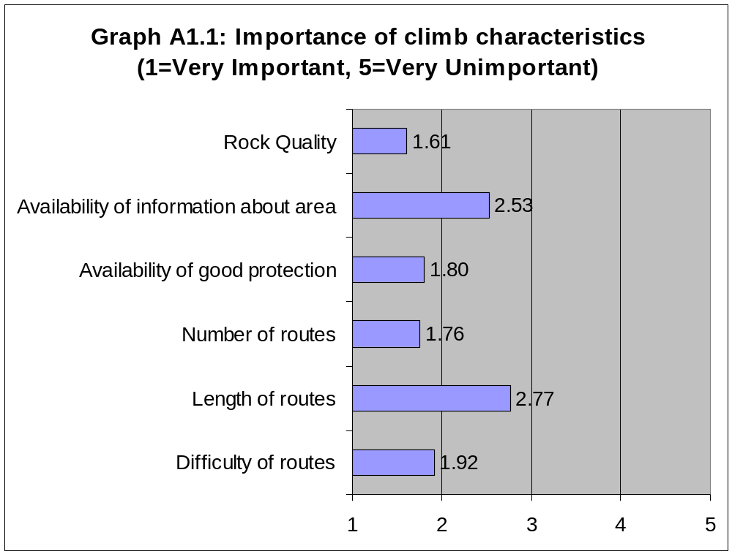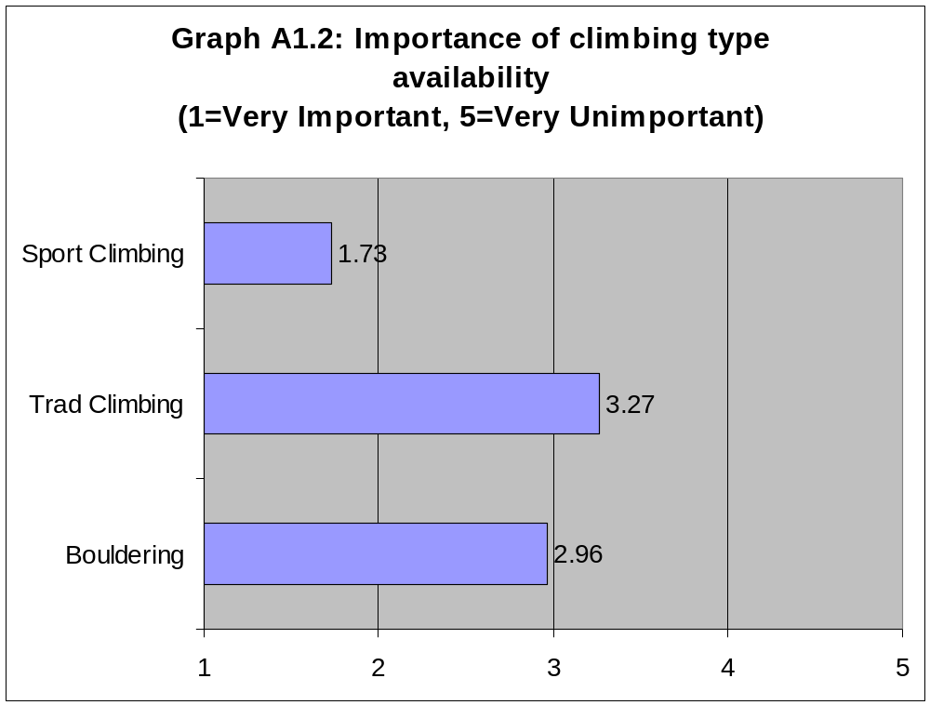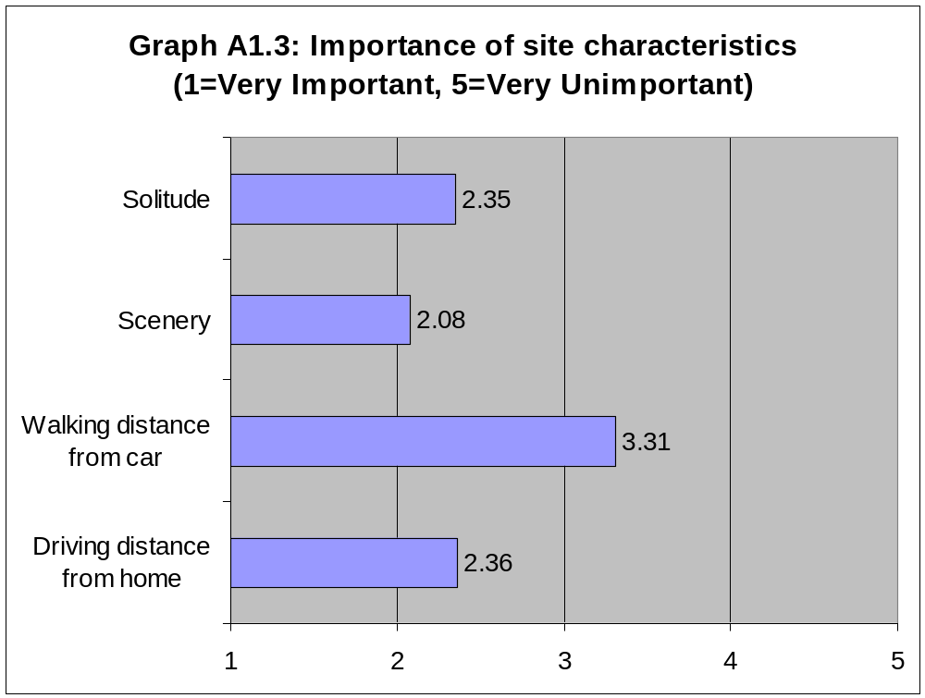

A.2 Evaluations of Obed WSR
rock climbing sites

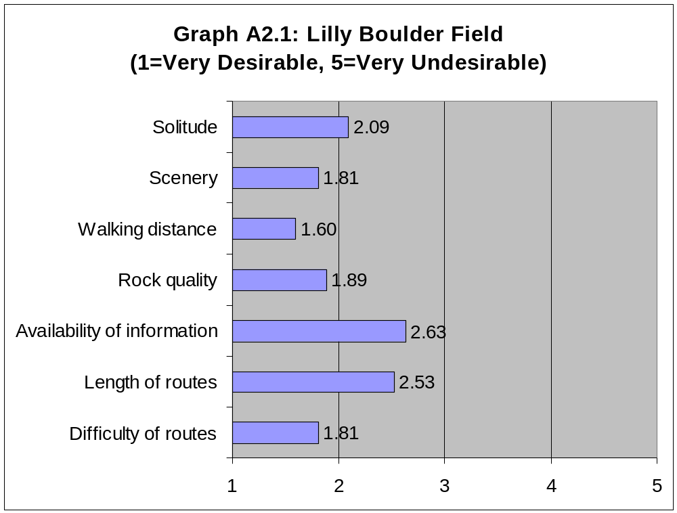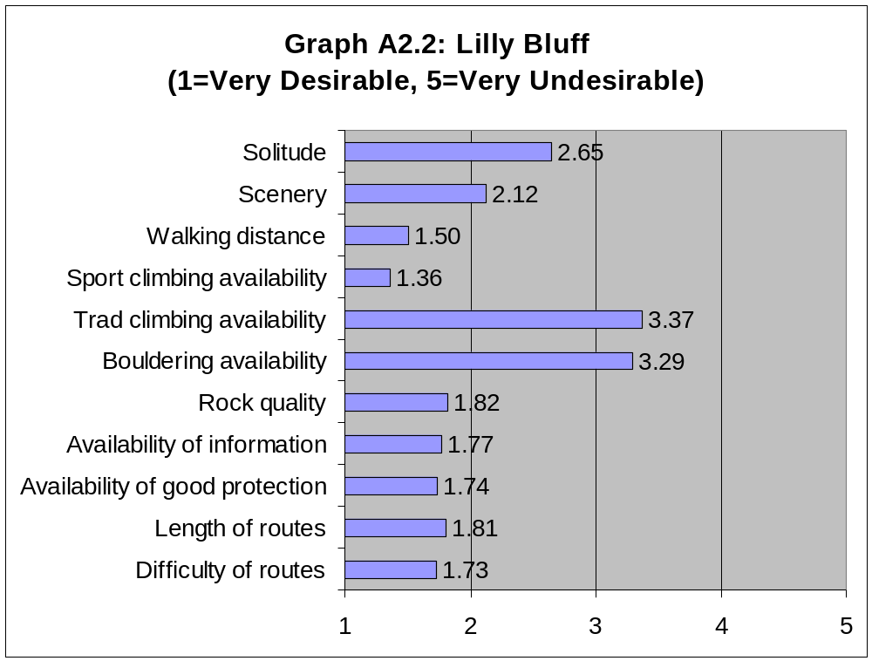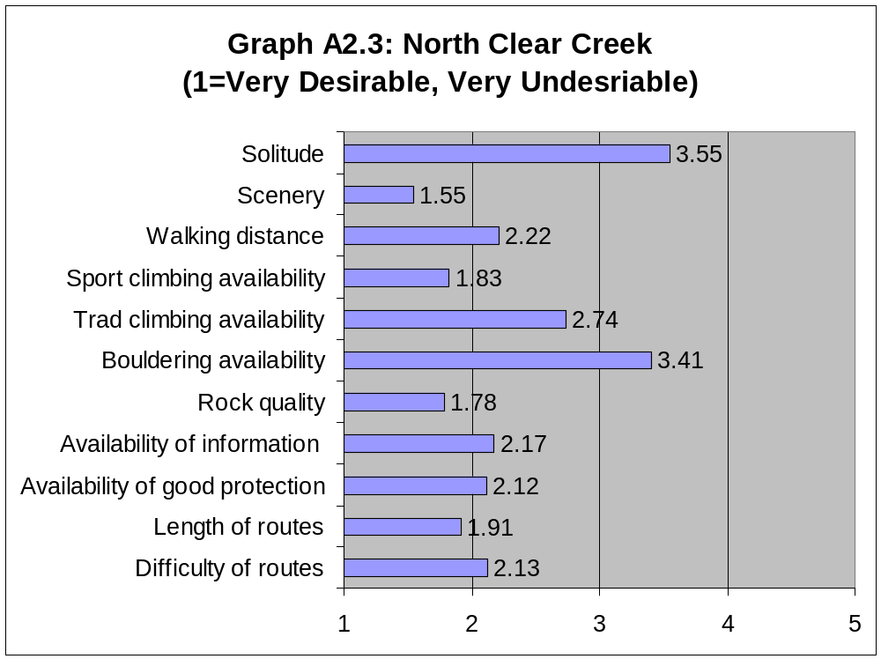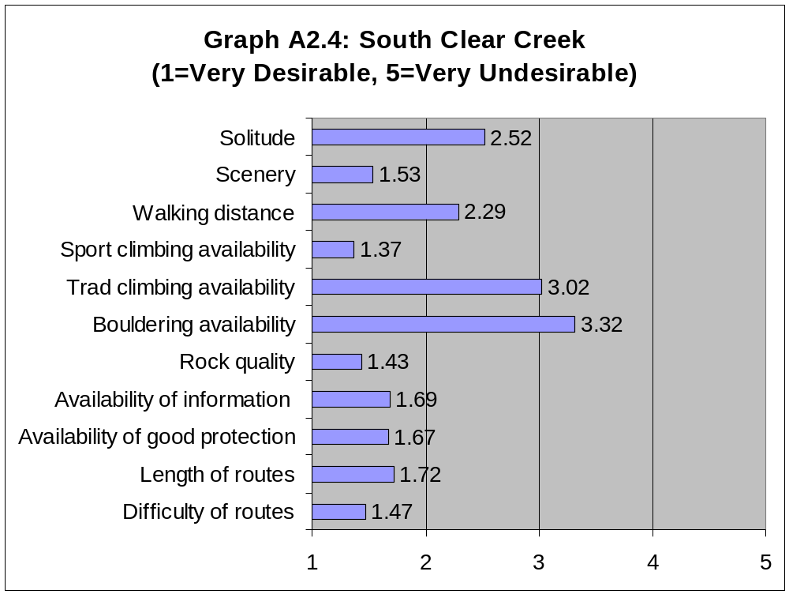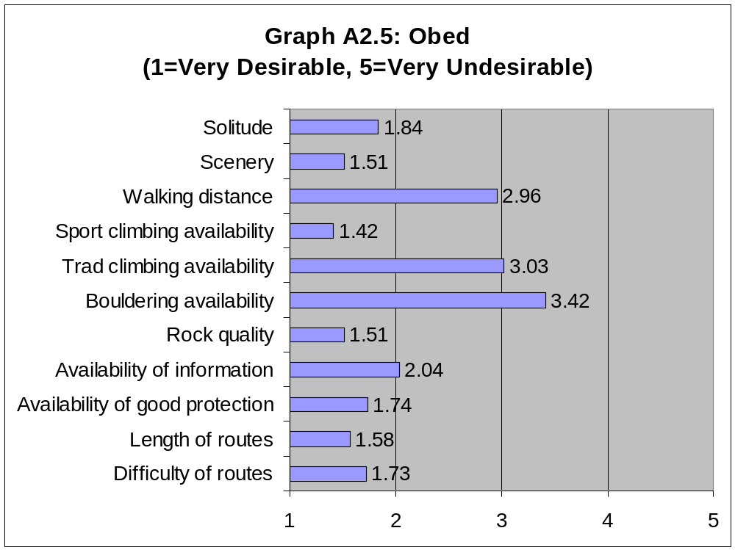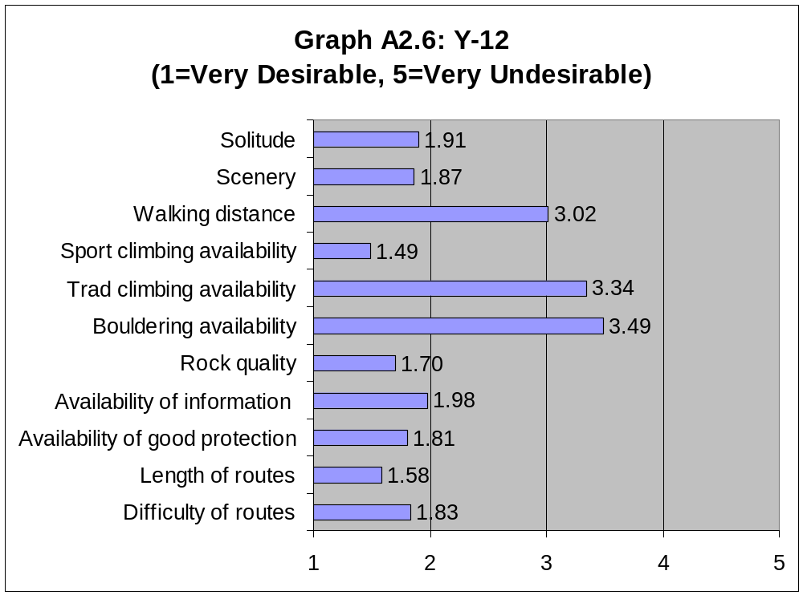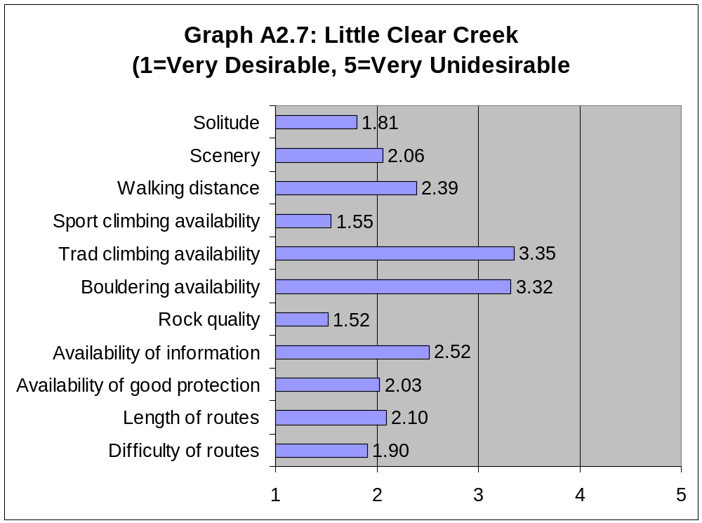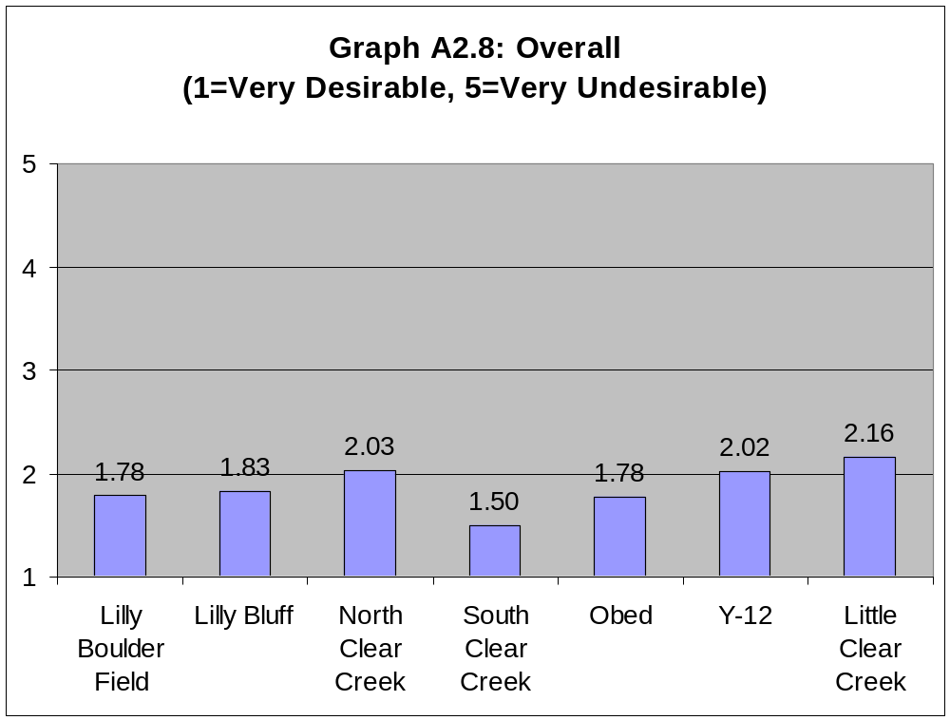

A.3 Perceptions of management
issues at the Obed WSR

Table A3.1: Average perception of management issues
1=Not a Problem; 5=Serious Problem
Visitor Issue | Average Response | Std Dev
Too many rules and regulations | 1.67 | 1.12
Too few rules and regulations | 1.63 | 1.03
Poor communication of rules and regulations | 2.11 | 1.24
Lack of adequate protection | 1.73 | 1.54
Impacts to vegetation | 2.23 | 1.09
Impacts to soil | 2.20 | 1.07
Poor access | 1.54 | 0.87
Traffic around climbing area | 1.85 | 1.11
Litter | 2.19 | 1.17
Availability of parking at access points | 1.58 | 0.84
Lack of facilities at access points | 1.73 | 1.10
Lack of designated routes | 1.30 | 0.65
Crowds or long lines | 1.87 | 1.07
Vandalism | 1.85 | 1.26
Lack of suitable campsites | 2.86 | 1.52
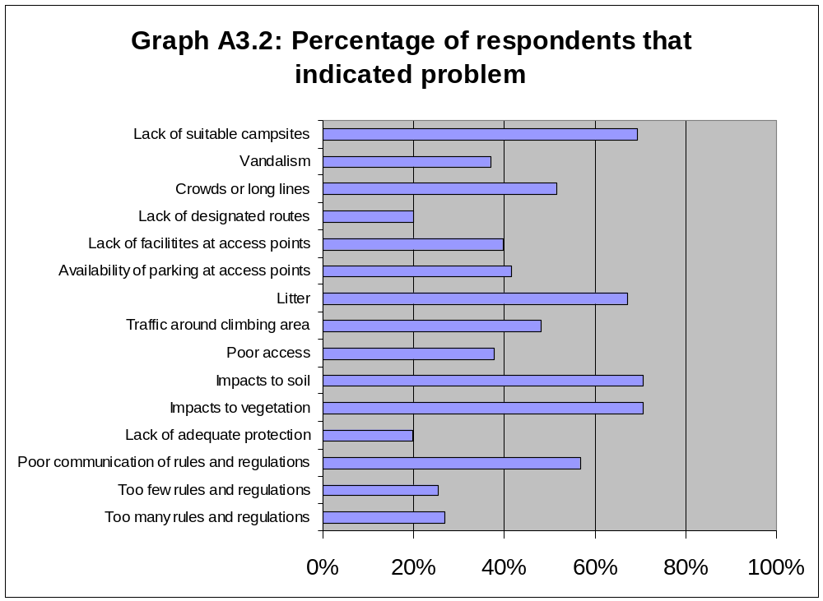

A.4 Motivations for rock

climbing at the Obed WSR

Table A4.1: Average motivations for rock climbing
1=Strongly Agree; 5=Strongly Disagree
Reason | Average Response | Std Dev
Get away from crowds | 2.77 | 1.00
Enjoy natural scenery | 1.65 | 0.64
Be with others with similar interests | 1.95 | 0.81
Do something challenging | 1.38 | 0.53
To be alone | 3.56 | 0.89
Explore places where I have not been | 2.42 | 0.92
Keep physically fit | 1.71 | 0.70
Experience excitement | 1.71 | 0.77
Rest mentally | 2.20 | 0.93
Get away from everyday life | 1.86 | 0.83
Talk to new and varied people | 2.26 | 0.83
Develop and test my skills and abilities | 1.42 | 0.54
Experience a sense of personal freedom | 1.81 | 0.84
Be with my friends | 1.68 | 0.69
Feel more self-confident | 2.32 | 0.79

Characteristics of Rock Climbers at the Obed WSR

B.1 Demographics of rock climbers at the Obed WSR

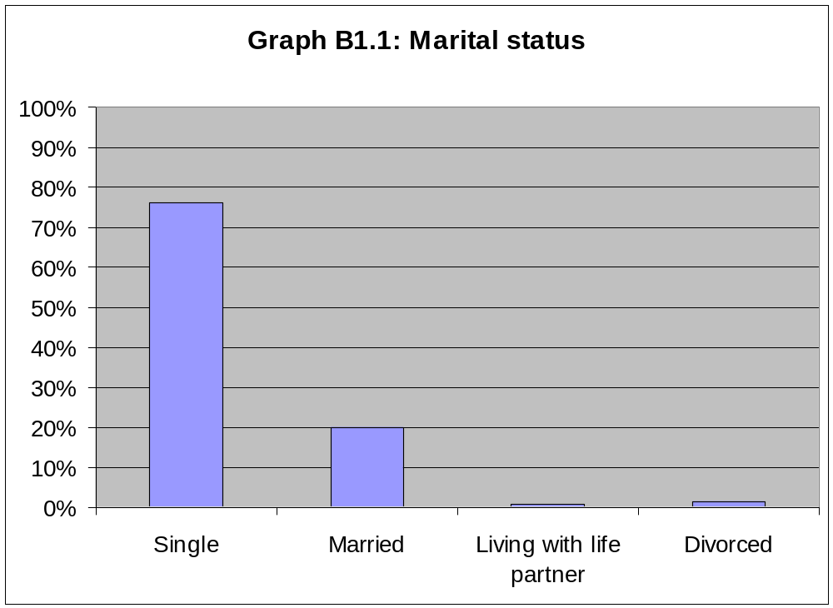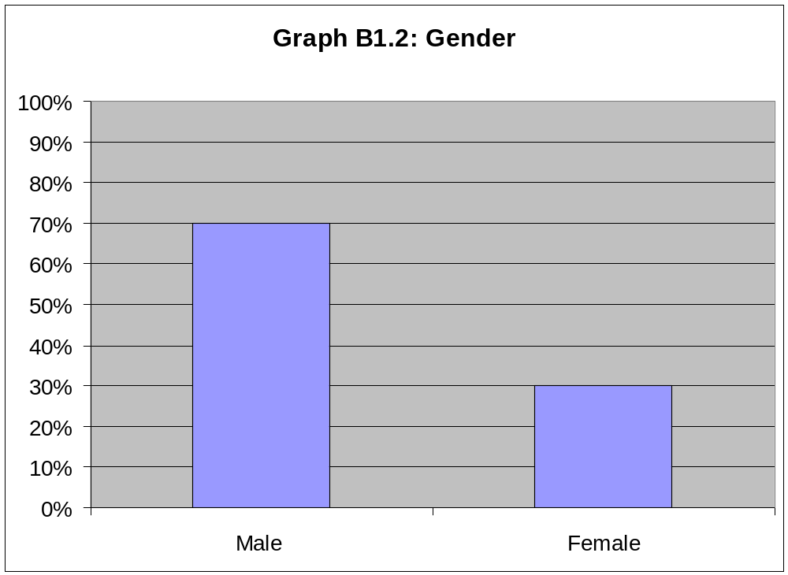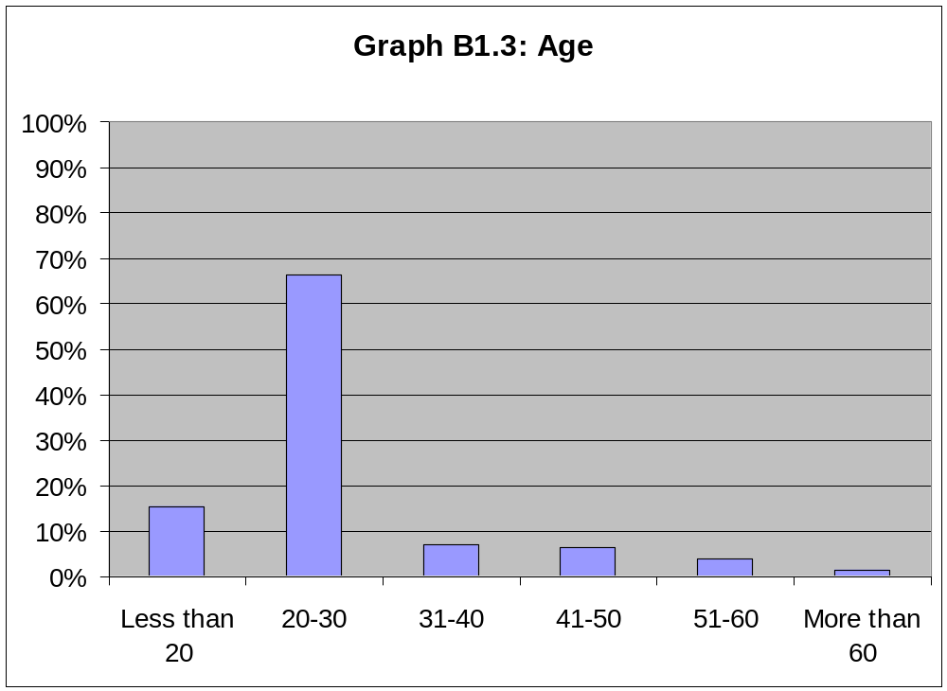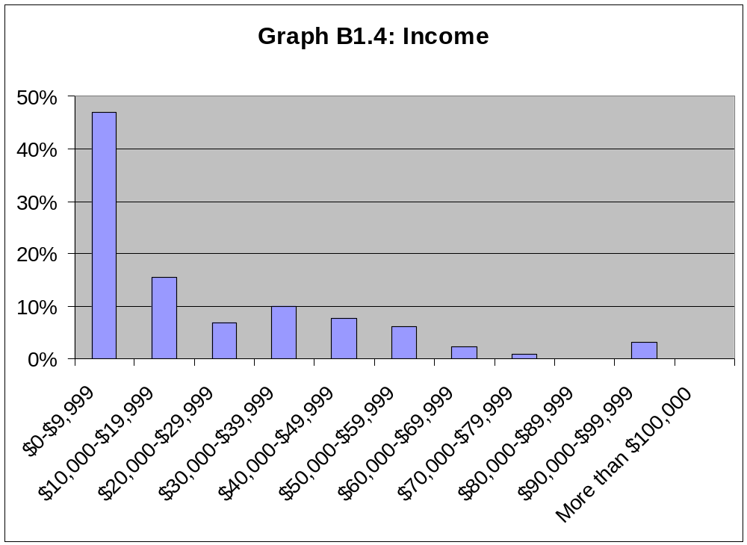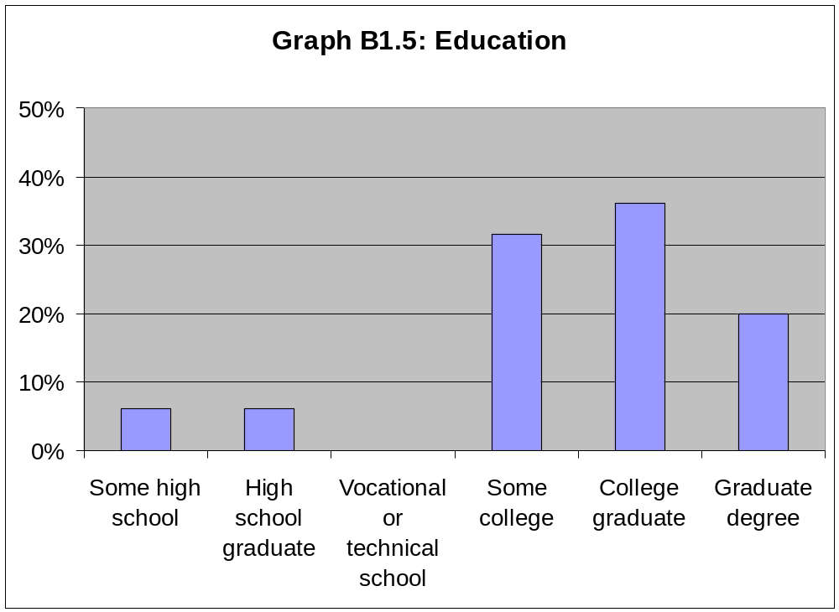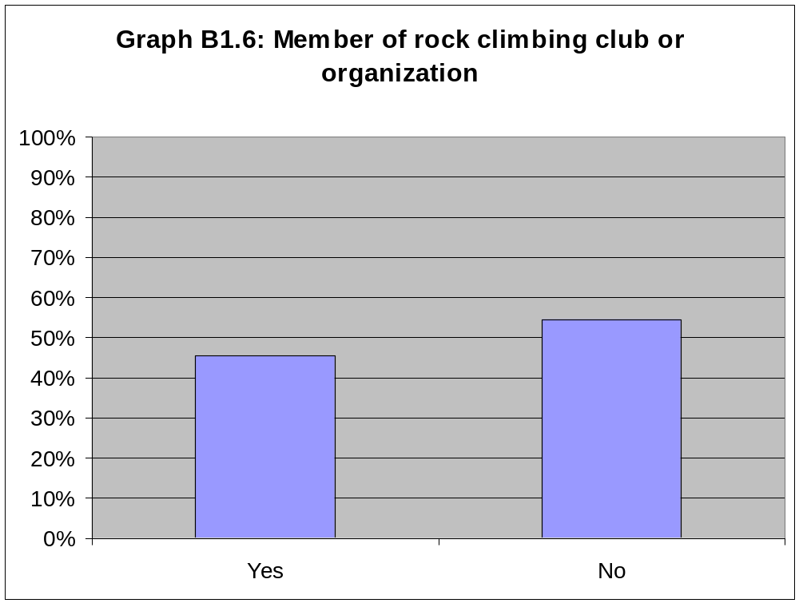

B.2 Experience and skill level of
rock climbers at the Obed WSR

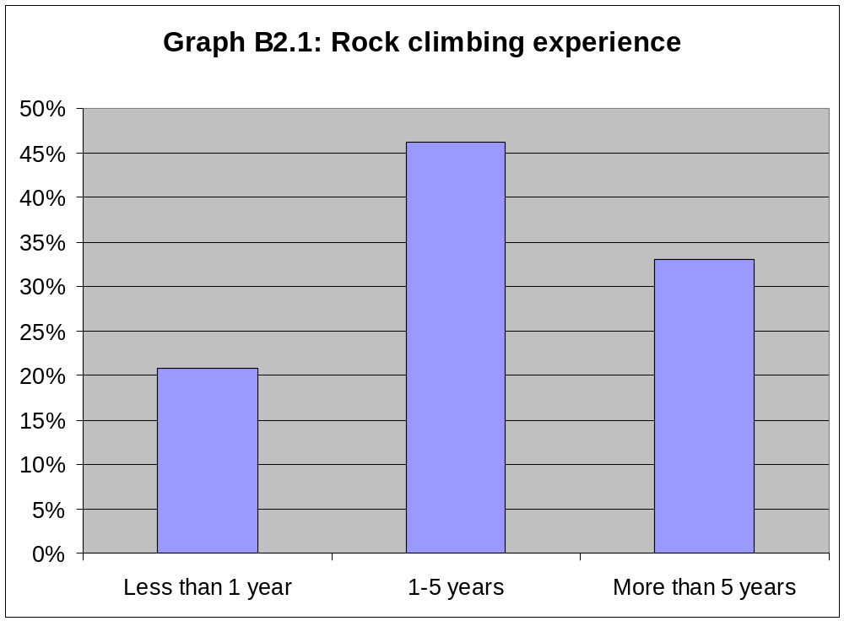
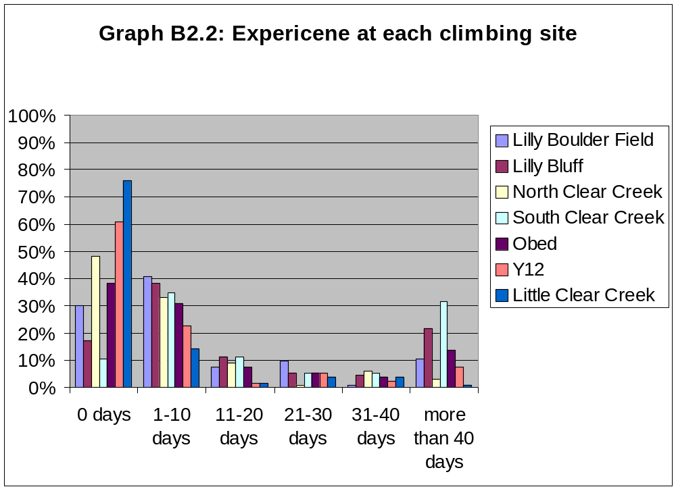
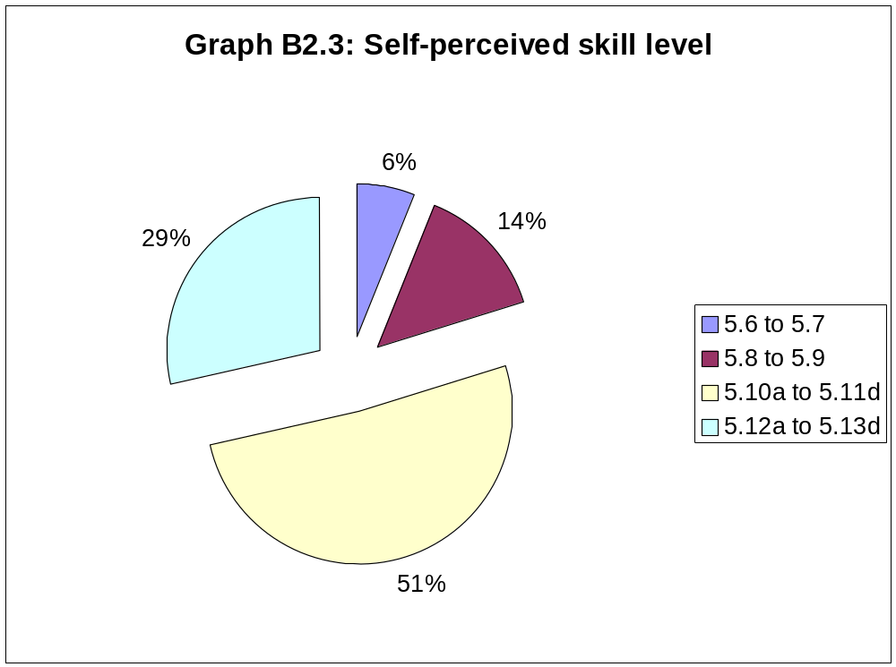

- Aspects of Climbing Use and Trip
Characteristics

C.1 Type and amount of climbing use

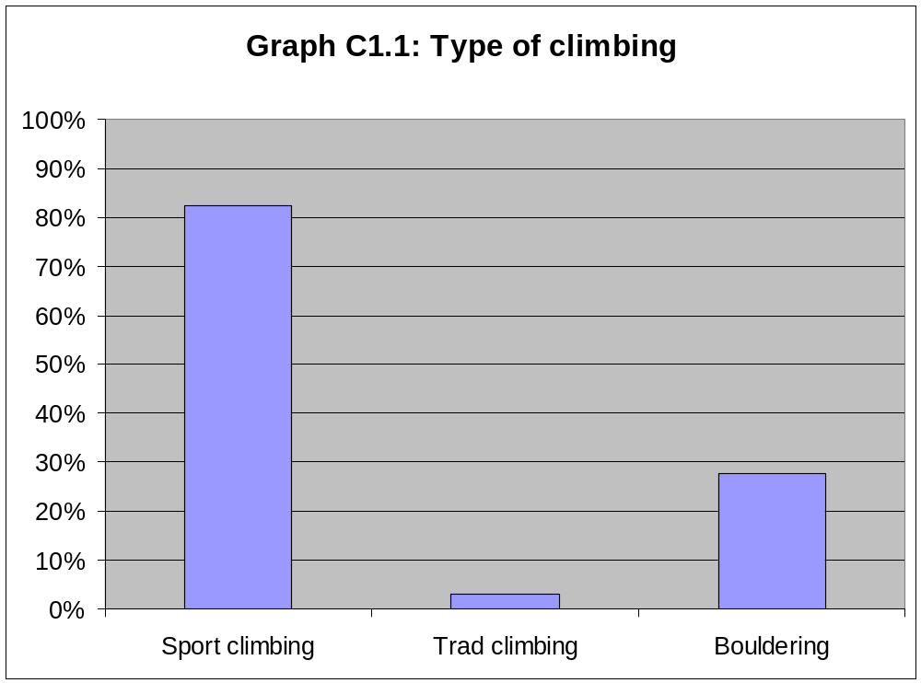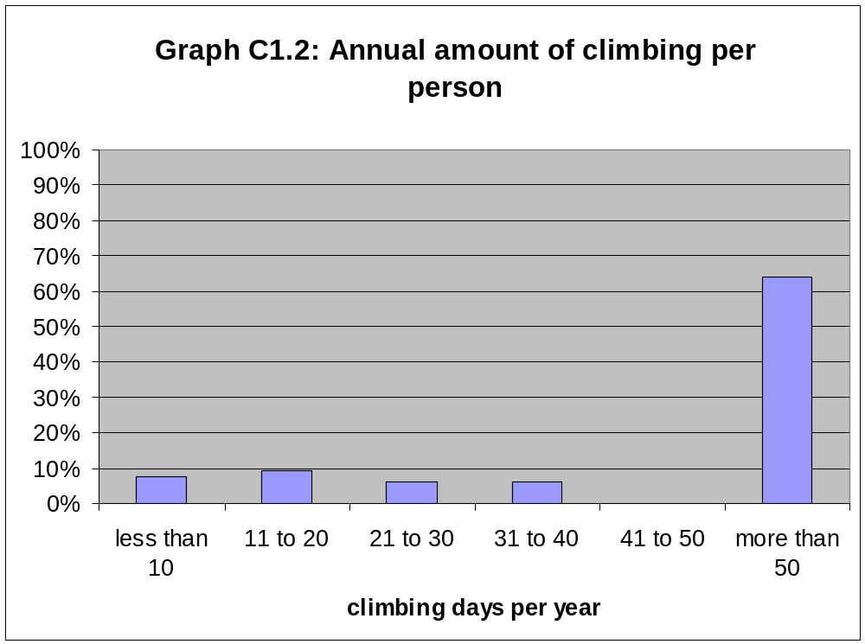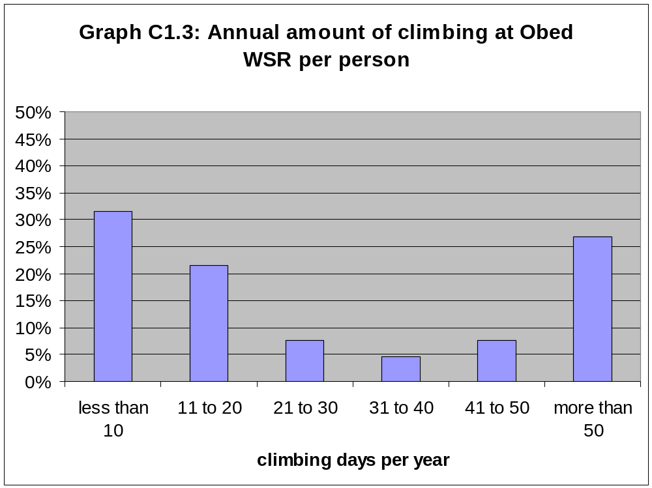
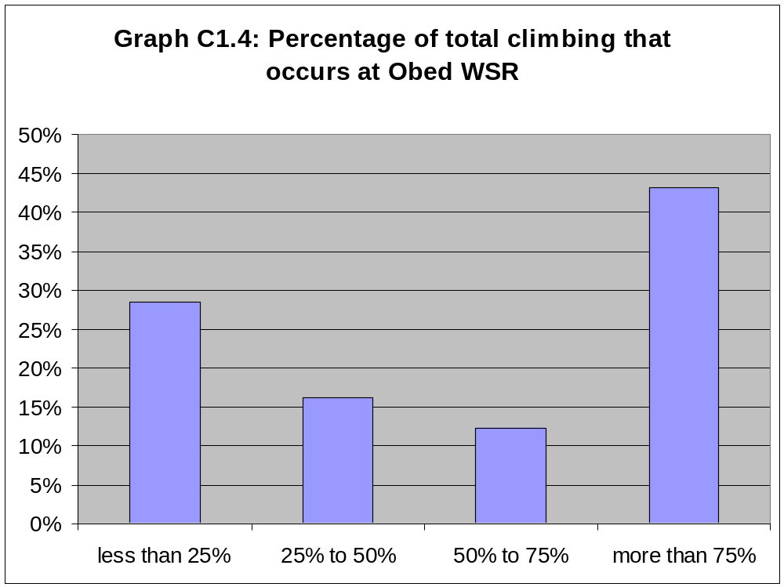
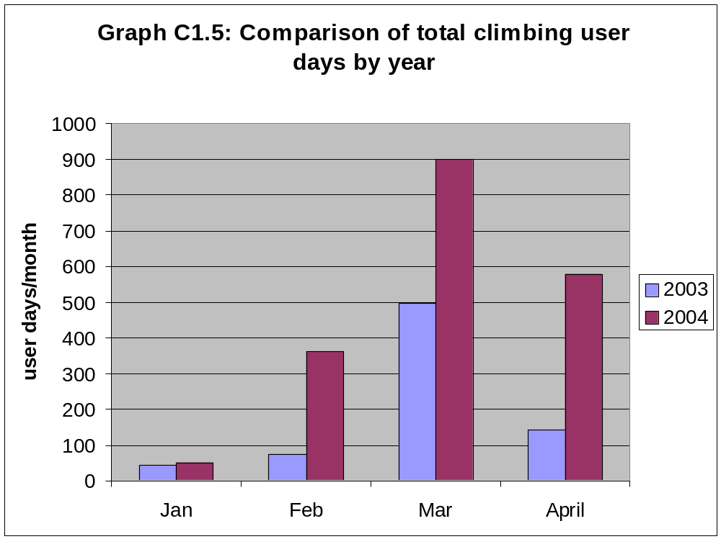

Table C1.6: Total annual climbing user days at Obed WSR by site
 | 2003 | 2004 | Avg.
Clear Creek | 1299.375 | 1856.875 | 1604.375
Lilly Bluff | 593.375 | 873.875 | 816.125
Obed/Y12 | 87.25 | 132.25 | 121
Lilly Boulders | 533 | 651.5 | 624.125
Total | 2513 | 3514.5 | 3165.625

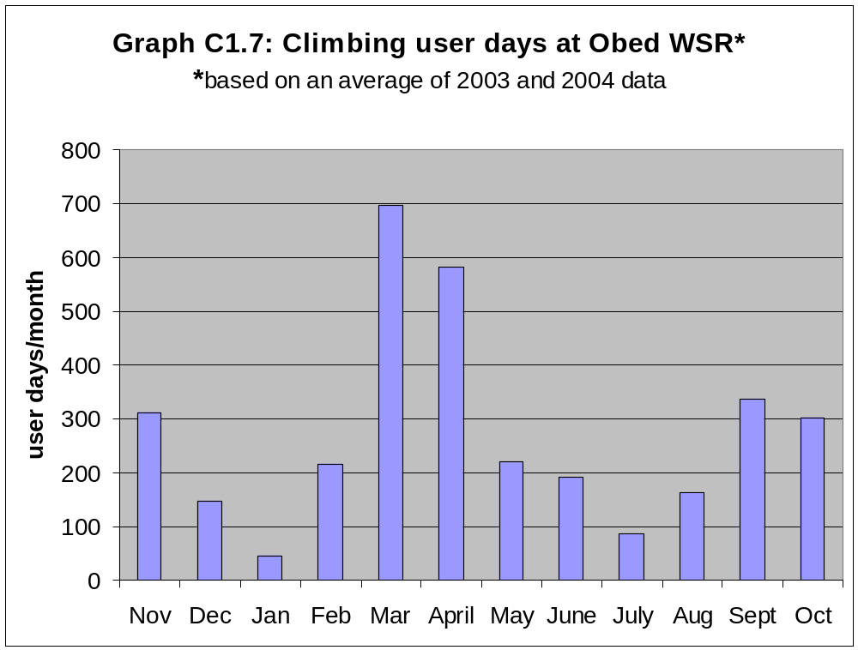
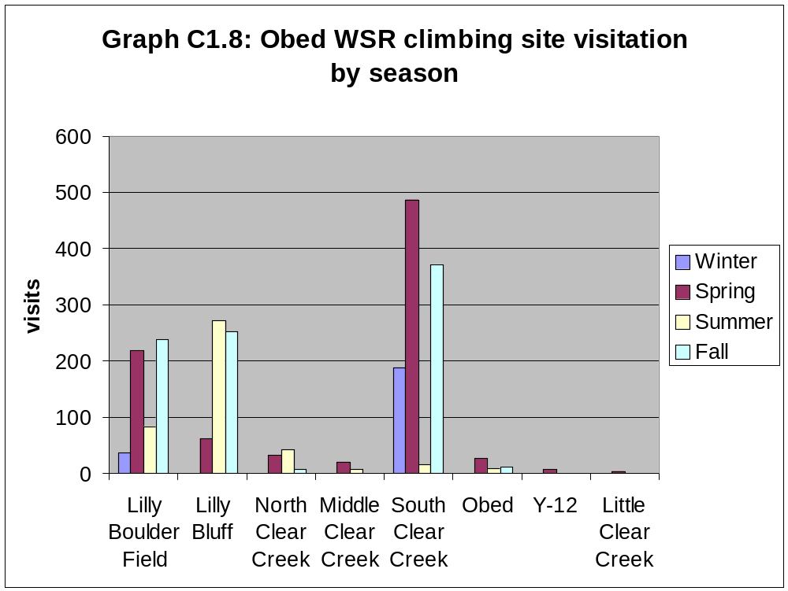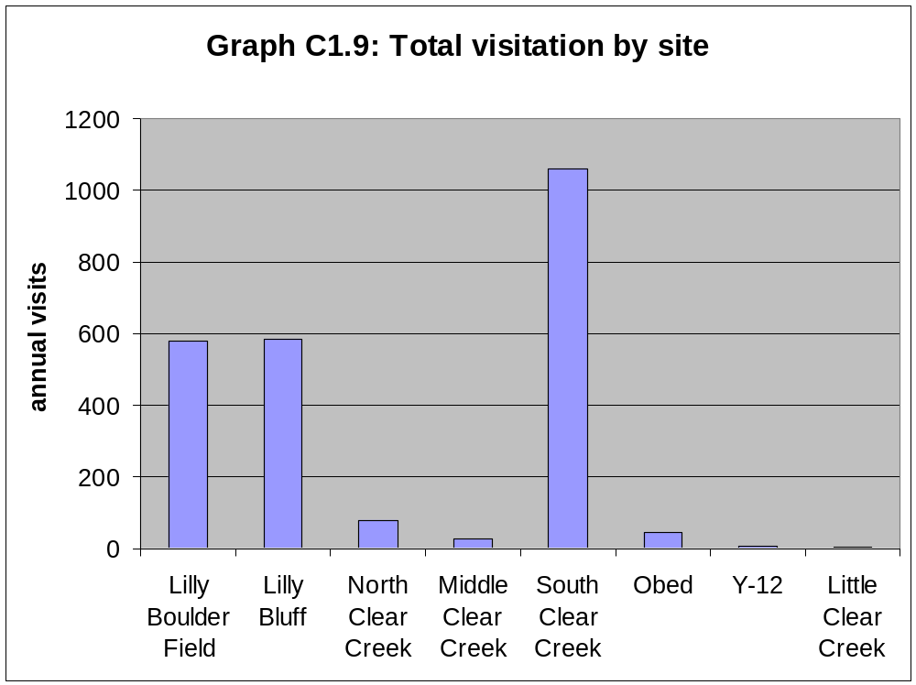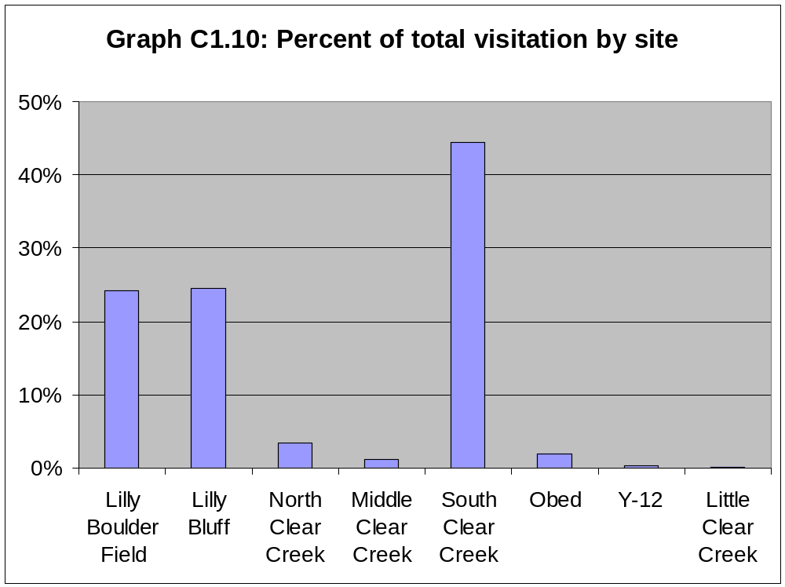

C.2 Trip characteristics

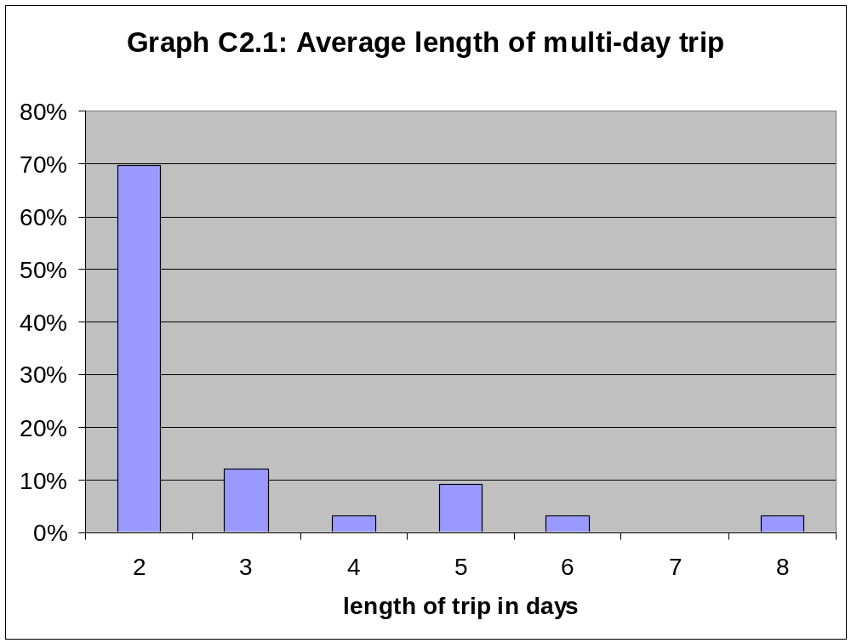
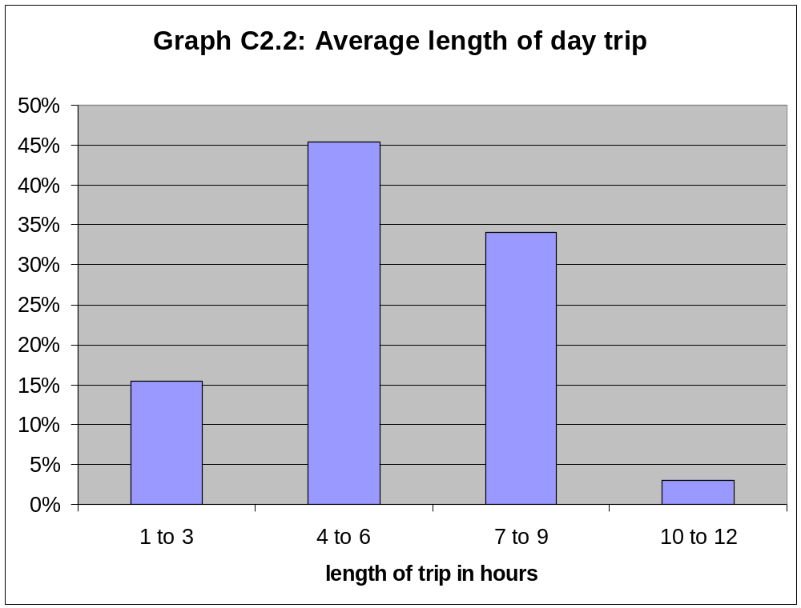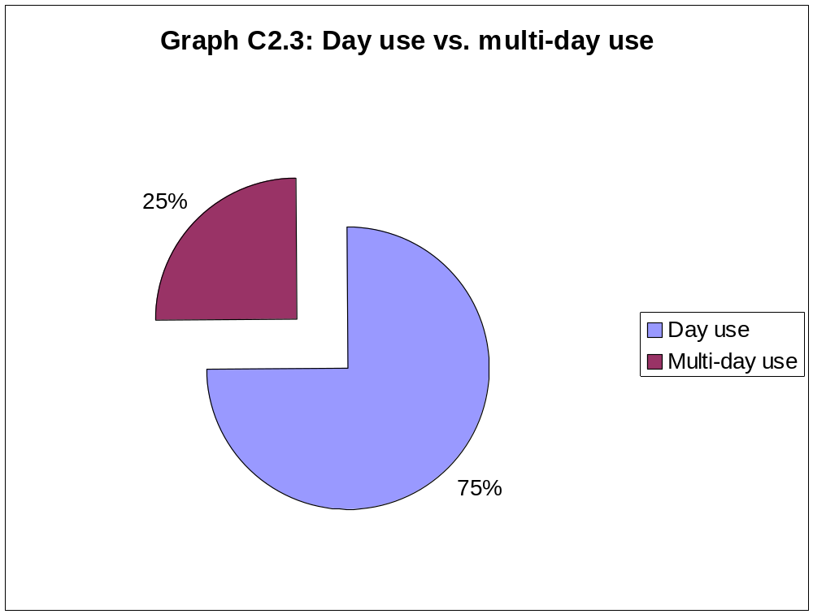
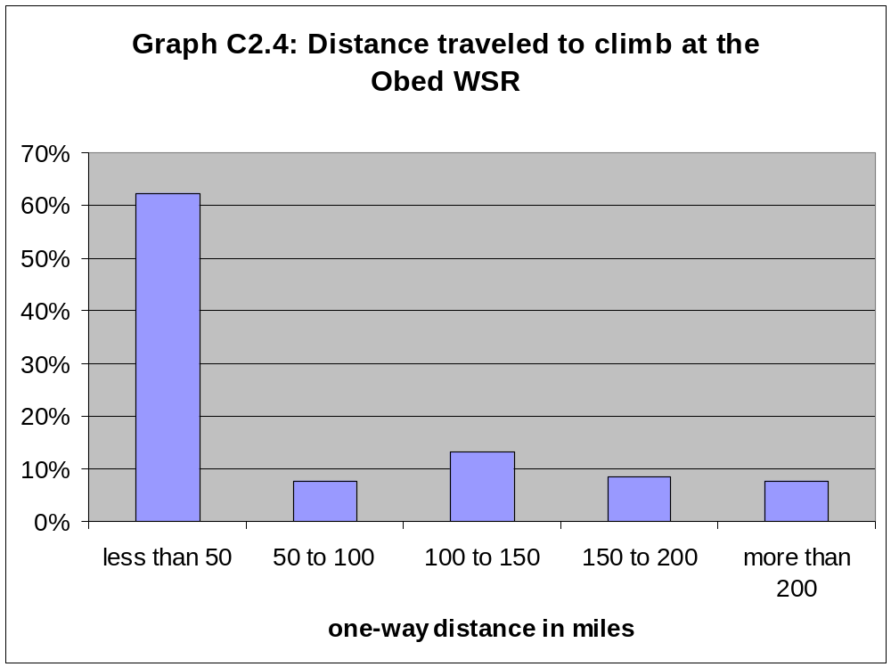

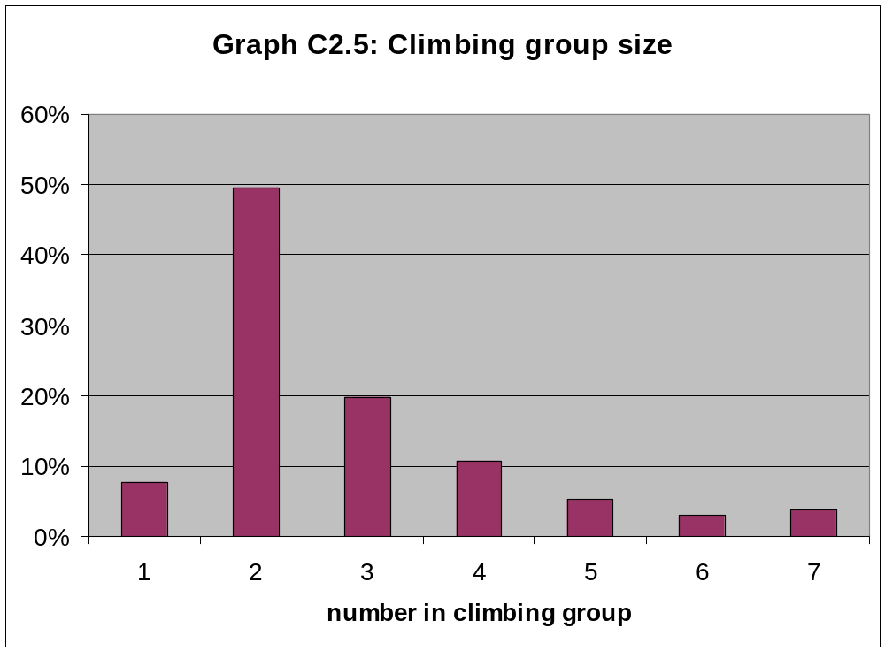

- Trip Expenditures and Economic
Impact

D.1 Trip Expenditures

Table D1.1: Average trip expenditures by category
Lodging | Food and | Transportation | Activities and | Miscellaneous | Total
 | Beverage |  | Entertainment
$4.88 | $20.65 | $15.19 | $0.18 | $5.32 | $46.20

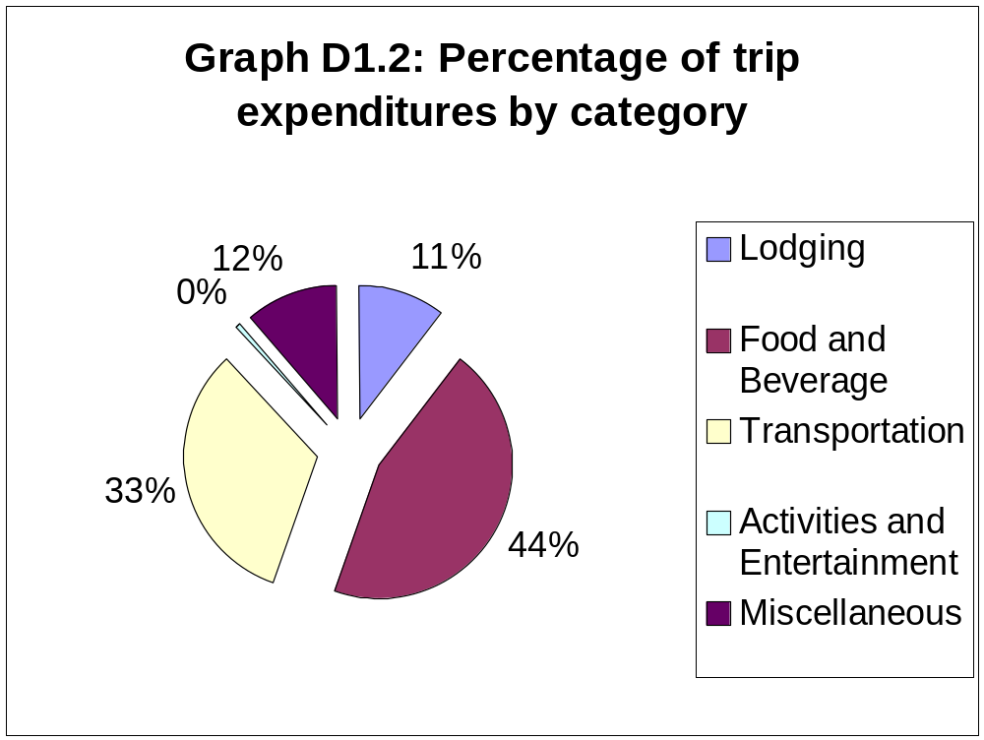
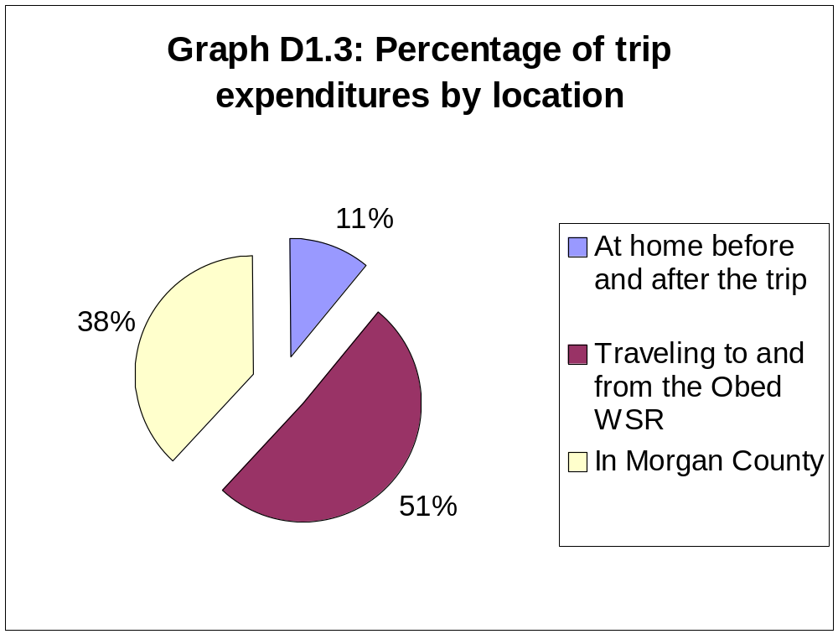

D.2 Economic Impact

Table D2.1: Direct economic impact by month*
*based on an average of 2003 and 2004 data
 | User Days | Economic Impact
January | 46.5 | $2,148.30
February | 217 | $10,025.40
March | 697.5 | $32,224.50
April | 579 | $26,749.80
May | 220.875 | $10,204.43
June | 191.25 | $8,835.75
July | 85.25 | $3,938.55
August | 162.75 | $7,519.05
September | 337.5 | $15,592.50
October | 302.25 | $13,963.95
November | 311.25 | $14,379.75
December | 147.25 | $6,802.95
Total | 3165.625 | $146,251.88

- Travel Cost Model

E.1 Poisson regression variables

Table E1.1: Definition of Poisson regression variables
Variable
TC | Expenditures incurred while visiting the Obed WSR
RCGRP | Dummy variable = 1 if member of a rock climbing group or organization
INC | Annual personal income of the respondent
MILES | Miles traveled to climb at the Obed WSR
BLDR | Dummy variable = 1 if respondent participates in bouldering
DAY | Dummy Variable = 1 if respondent was on a day trip
CLIMBS | Number of climbs in climber's ability range
SUBS | Average travel costs measured in miles for traveling to substitute sites

Table E1.2: Mean and standard deviation of Poisson regression variables
Variable | Mean | Standard deviation
TC | 60.5590 | 62.1300
RCGRP | 0.4538 | 0.4979
INC | 2.6923 | 2.2286
MILES | 153.8419 | 143.7519
BLDR | 0.2769 | 0.4475
DAY | 0.7462 | 0.4352
CLIMBS | 148.5154 | 81.5468
SUBS | 282.4805 | 62.6191

E.2 Results of Poisson regression
Table E2.1: Poisson regression results
Variable | Coefficient | Std Error
Constant | 1.0253* | 0.6235
TC | -0.0059** | 0.0018
RCGRP | 0.2616* | 0.1339
INC | 0.0614* | 0.0264
MILES | -0.0022 | 0.0015
BLDR | 0.2129 | 0.1280
DAY | 1.0111** | 0.2498
CLIMBS | -0.0007 | 0.0009
SUBS | 0.0068** | 0.0028
N=140
R-Square=0.4389
Chi-Squared=1839.80
Restricted Log Likelihood=-1960.26
** significant at the 1% level
* significant at the 5% level

Table E2.2: Elasticities and marginal effects
Variable | Elasticity | Marginal Effect
TC | -0.3549 | -0.1876
RCGRP | - | 8.3712
INC | 0.1654 | 1.9655
MILES | - | -0.0718
BLDR | - | 6.8130
DAY | - | 32.3541
CLIMBS | - | -0.0216
SUBS | - | 0.2189

E.3 Value of rock climbing at the
Obed WSR

Table E3.1: Consumer surplus for rock climbing at the Obed WSR*
*based on an average of 2003 and 2004 data
 | Individual | Per-Day | Annual Consumer
Annual Individual | Per-Trip | Consumer | Surplus
Consumer Surplus | Consumer Surplus | Surplus | Obed WSR
$6,903.58 | $170.62 | $113.75 | $360,121.17

Appendices

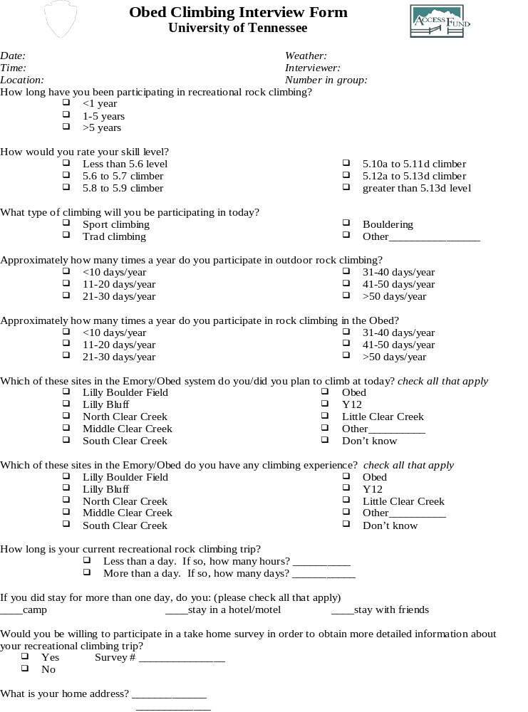
- Appendix 1 (On-site interview)
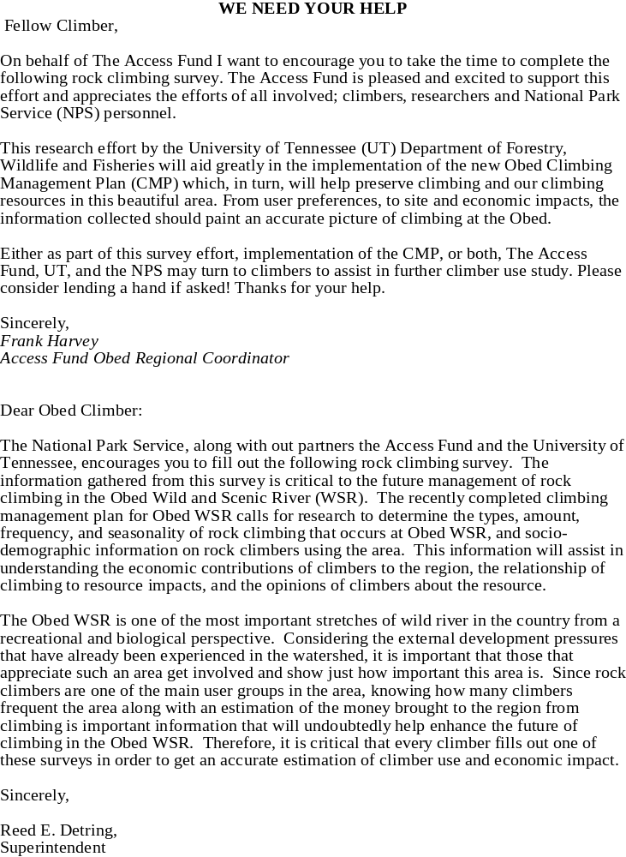
- Appendix 2 (Mail survey)

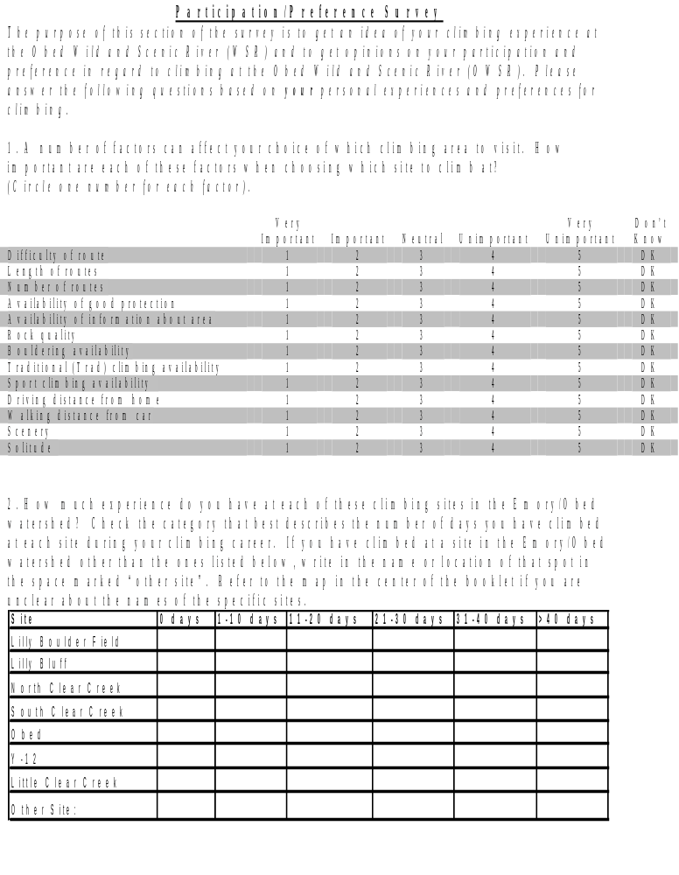

3. The following is a list of climbing sites at the Obed WSR. Compare the rock climbing at the following sites in relation to the factors listed in the first column using the 1 through 5 scoring system listed below. If you have not climbed at a particular site, check the box in the row labeled “No experience at this site” for the corresponding site and simply leave that column blank. Base your comparison solely on your experiences at the OWSR and do not compare your opinions and experiences at other climbing sites like Foster Falls or Tennessee Wall to your rating of the following sites in the OWSR. Base all ratings only on sites located in the Obed WSR. If you have not climbed at any site in the Obed WSR other than those identified below, simply leave the “Other Site” column blank. If you have climbed at another site, please identify the site in the “Other Site” Column and evaluate it.

Score using the following system:
1= Very Desirable
2= Desirable
3= Neutral
4= Undesirable
5= Very Undesirable
 | Lilly Boulder Field | Lilly Bluff | North Clear Creek | South Clear Creek | Obed | Y-12 | Little Clear Creek | Other Site:  __________
No experience at this site
Example:
Difficulty of routes
Difficulty of routes
Length of routes
Availability of good protection
Availability of information about the area
Rock quality
Bouldering availability
Traditional (Trad) climbing availability
Sport climbing availability
Driving distance
Walking distance
Scenery
Solitude
Overall

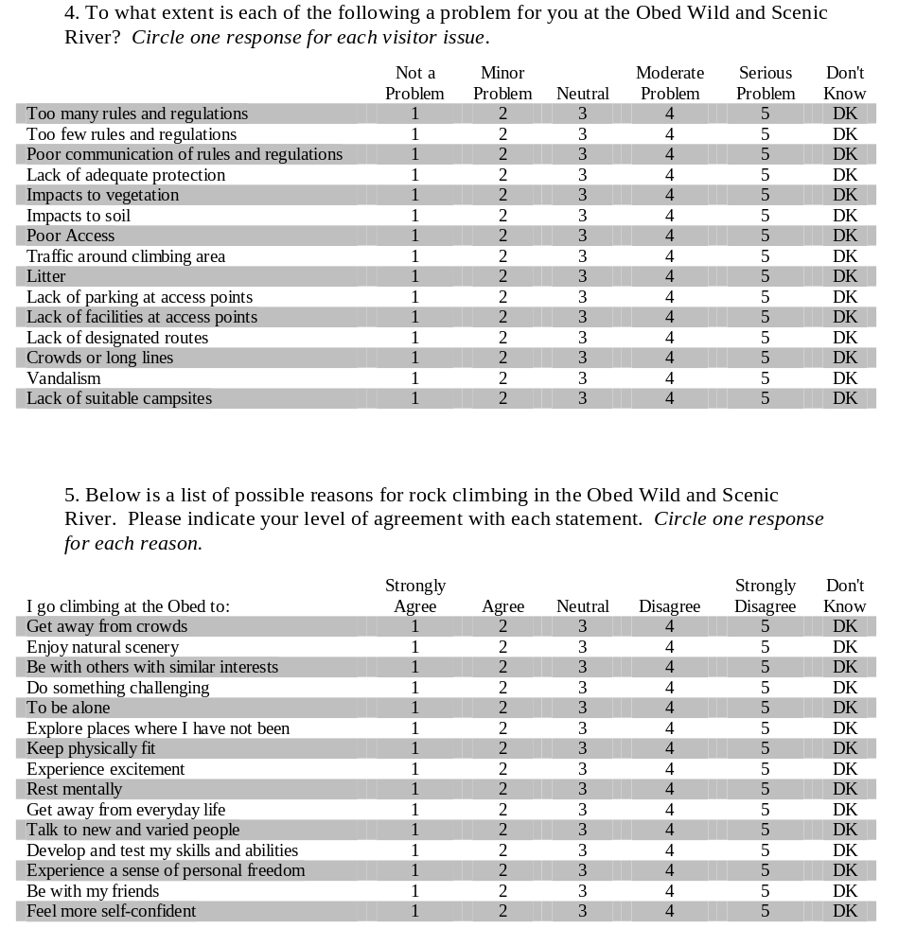

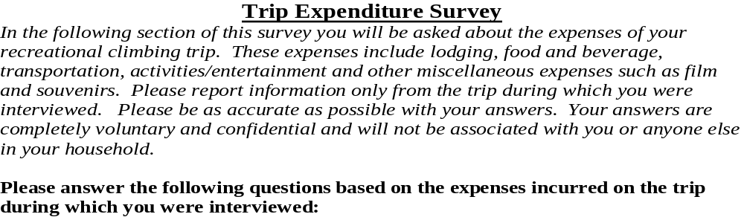
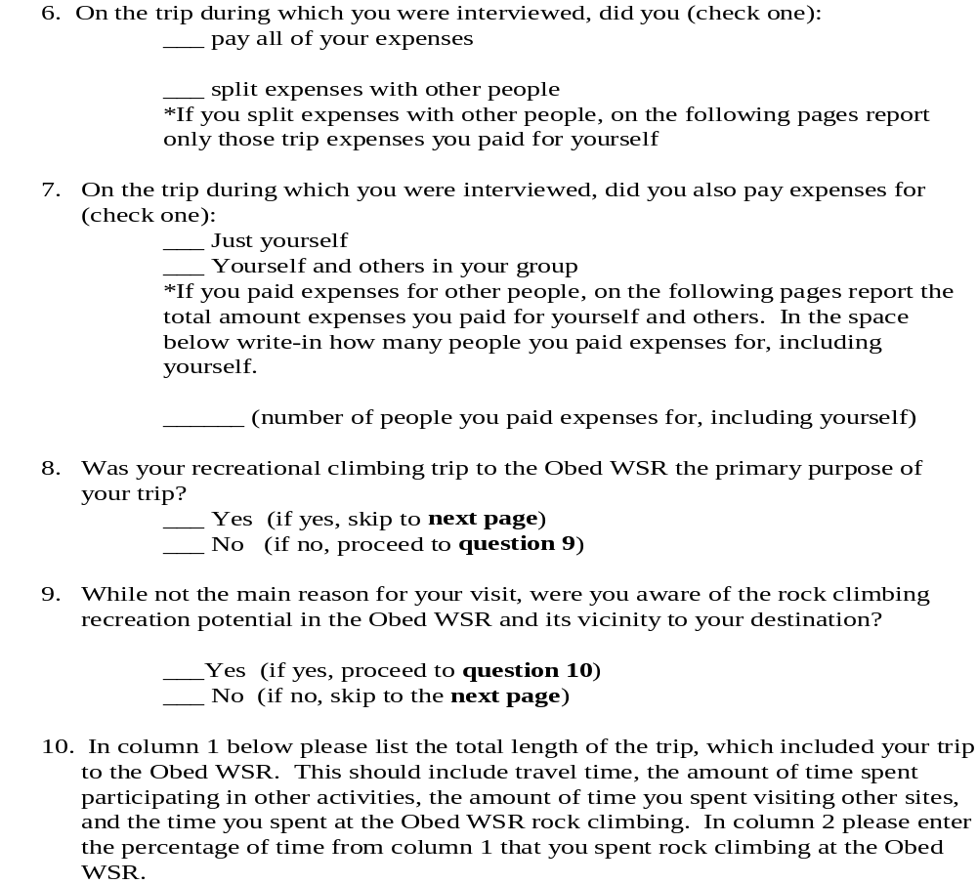

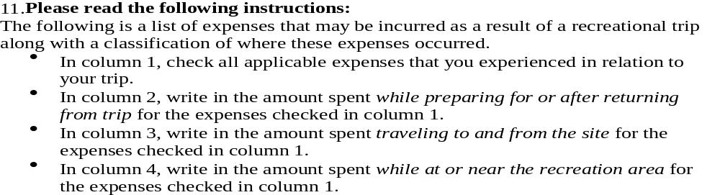
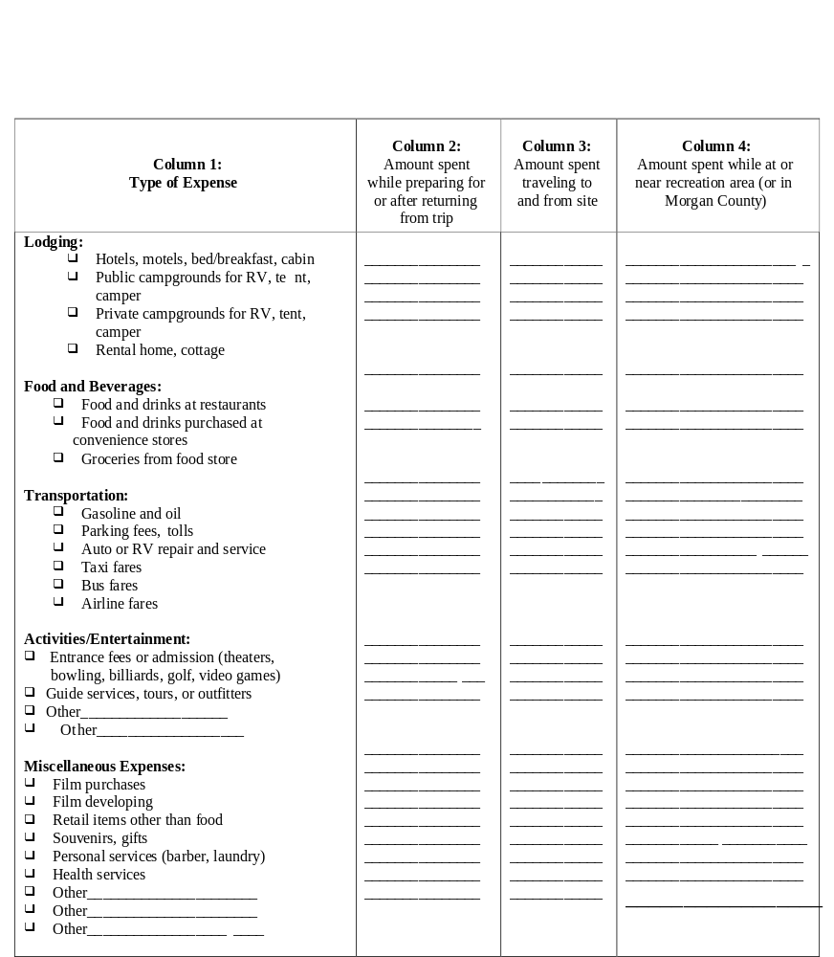

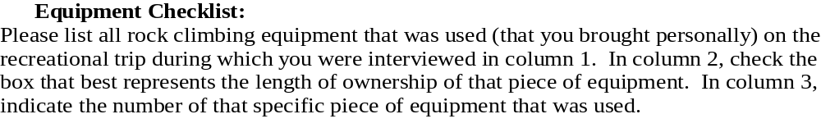
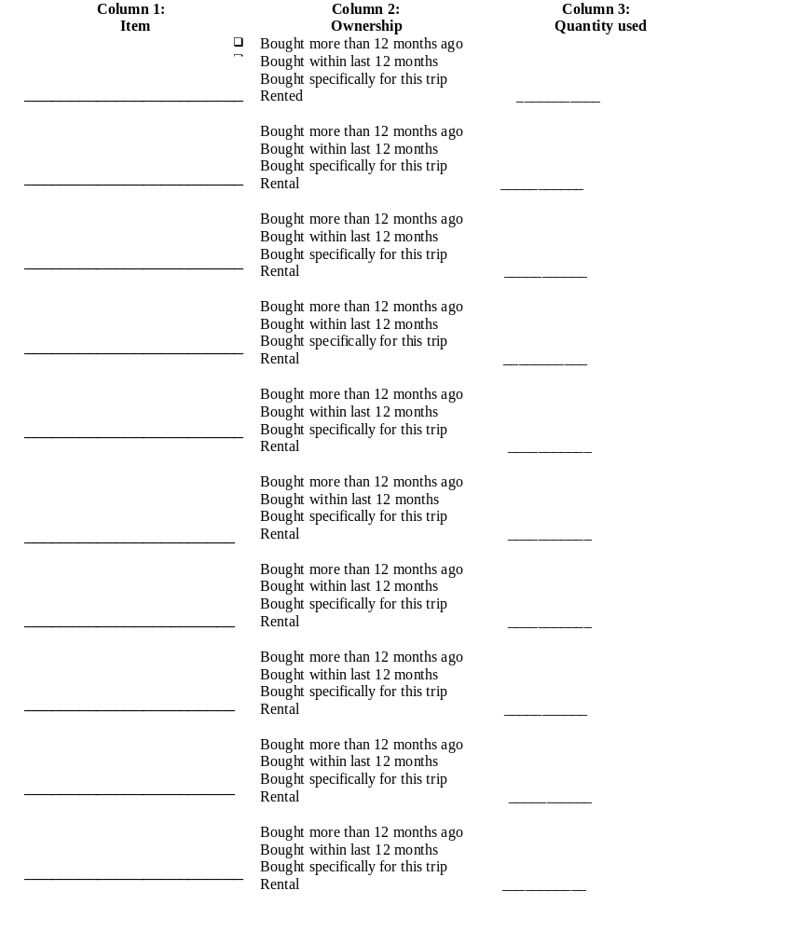

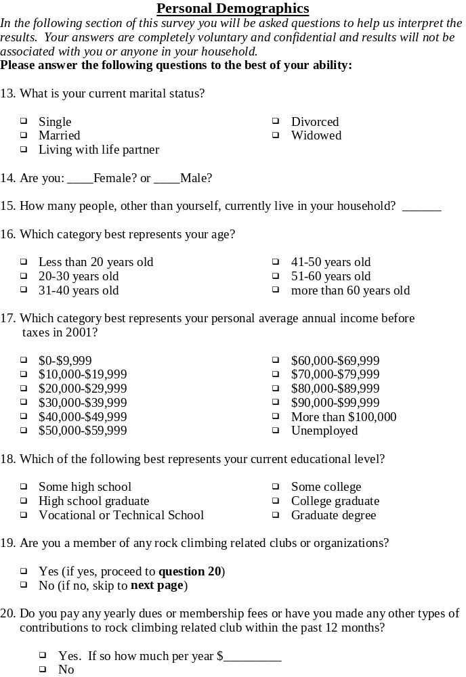

- Appendix 3 (Comments from survey respondents)

  - I enjoy the freedoms at the Obed i.e. not many rules like having to be out before dark, dogs can run free, not overcrowded like other areas. Would be nice if it remains like this.
  - I am willing to support a plan to protect this area, but I’d like to emphasize 2 things: 1) One of the nicest things about climbing is that, except for gear, it’s cheap. Steep, mandatory, daily charges would discourage me. 2) Strict regulations are a big pain. I’d be more willing to do volunteer trail maintenance or litter clean up than to have some anal guy walking around checking registration tags. Let the people who climb there take some ownership and responsibility.
  - OWSR is one of my favorite places to climb. Also one of the big reasons I live in Cumberland Co. just 30 mins away. It is a gorgeous area my friends and I also use to hike and kayak in. Please keep this wonderful place from becoming a fee area! Keep the outdoors free! (esp. for the poor folk of America!)
  - I enjoy climbing at the Obed. The bolted routes on sandstone are excellent alternatives to the granite trad routes I normally climb in North Carolina. I appreciate everyone’s efforts in creating and maintaining these wonderful resources and I hope to visit again many times in the future.
  - Obed needs to limit the size of the school groups they allow in the park. They end up spending hours on the best routes there and prohibit others from trying them. The restrooms also require intense attention. I didn’t see any toilet paper the whole time I was there and they need to be cleaned…badly!!
  - This was a recreation/business trip. Rock climbing and mountain biking opportunities influenced our desire to come to the area, our length of stay and the number of people in our party. Having traveled and climbed throughout the world, I can say that this is an important and quality area. (Except that it rains too much). Access to climbing and mountain biking areas are a concern and a growing problem.
  - This was my first visit to the Obed. I found everything as good as was expected. The natural beauty of this river is indespensible, this natural place of beauty should be preserved. All uses hikers, kayakers, climbers, tourists etc. should all respect the wonder of this place (as well as anywhere-even the high st). I as a climber therefore should always respect the area in which I climb, obey any access agreements, bird restrictions etc. It is not our devine right to climb any rock, but by grace we are able to enjoy the vertical places of beauty in this country and the world. Happy climbing!
  - Sorry this took so long for me to return!
  - My husband and I spend just about every weekend at the Obed. We actually got married at the Overlook, had our reception in the parking lot, then hit the river for swimming. We camped out for our honeymoon and enjoyed bouldering the next day!
  - I’m not a member of Access Fund, but have participated in their sponsored trail building and clean-up projects as well as other organizations and done route and area building and maintenance of my own.
  - I love to climb in all the areas mentioned and I do not want to see limited access to these areas or have to pay any access fee. I would also like to have easier access to Y12 and Obed if possible.
  - I recently moved here from Colorado. Obed is a beautiful place. I am fairly new at rock climbing and wish that you were allowed to top rope trees at Obed. This will encourage more beginners/intermediates to go to Obed.
  - Obed, Lilly, and Clear Creek areas are important to me because they are high quality and close to my home (60 miles). Some of the routes are well-protected. Some are over-protected (over bolted). Some routes should not have been bolted (would go with gear). It is my understanding that no more permanent anchors can be placed. This is unfortunate because I know of several trad climbs that would be used if there were belay anchors at the top.
  - Thanks for doing this survey!
  - Thank you!
  - Thanks for doing this. I found one typo. The easiest route at S. Clear isn’t 5.2d, that’s a typo in Dixie Craggers. It’s 5.7. The Obed is one of the greatest sport climbing areas in the country. I think it would be responsible to discourage growth of the area.
  - The trails need to be kept up better.
  - There is vandalism problem at Walden Ridge. Walden Ridge has about 10 routes. It is very close to Oak Ridge. But the red necks over there are very aggressive. Does the cop care?
  - As a beginner, I found the climbs at Lilly Bluff extremely difficult. If more routes and accessibility is to be established, it would be great is some easier routes for beginners were established. The Obed Wild and Scenic is a very beautiful area. This was our first experience climbing there and I hope to return after I acquire more experience. Since we live in northern Cumb Co., it is only a relatively short distance and we love the area. We live on Clear Creek, land that borders both sides on the Fentress Cumb County line so we have been very active in advocacy for the preservation of the Obed Wild and Scenic.
  - I travel to Obed from Florida about once per year. It particularly appeals to me because of the climber-friendly attitude of the rangers, the quality of the rock, the quality of the viewshed i.e. no powerlines, roads, or houses visible, and the relative freedom from excessive rules, fees, and manmade infrastructure. Plus, the creeks are great for swimming!
  - The Obed is an awesome climbing area. I have only been climbing for two years and have multiple crags nearer to my home, which take my interest. But I plan to take numerous trips to the Obed in the coming years.
  - Camping in the Obed is an issue. Since recently the boulderfield has been made off limits to camping. However, there is Del Scruggs, but many people don’t know he exists. I’m glad there is someone out there caring about the climbers and the places they climb. Thanks!
  - I would like to provide further expenditure information over a period of time. This particular trip was not the most accurate representation of my typical use primarily financially.
  - Thank you for the interest in the Obed. I’m glad I could be of some help.
  - I bolt and repair old routes: In short anchors at Obed need some attention. I would like to be able to make anchors safe without any paperwork and long waiting time. I have put in over 300 bolts and know a safe strong anchor is the best policy over risking a not safe one!

D. Appendix 4 (Climbing Site Map)
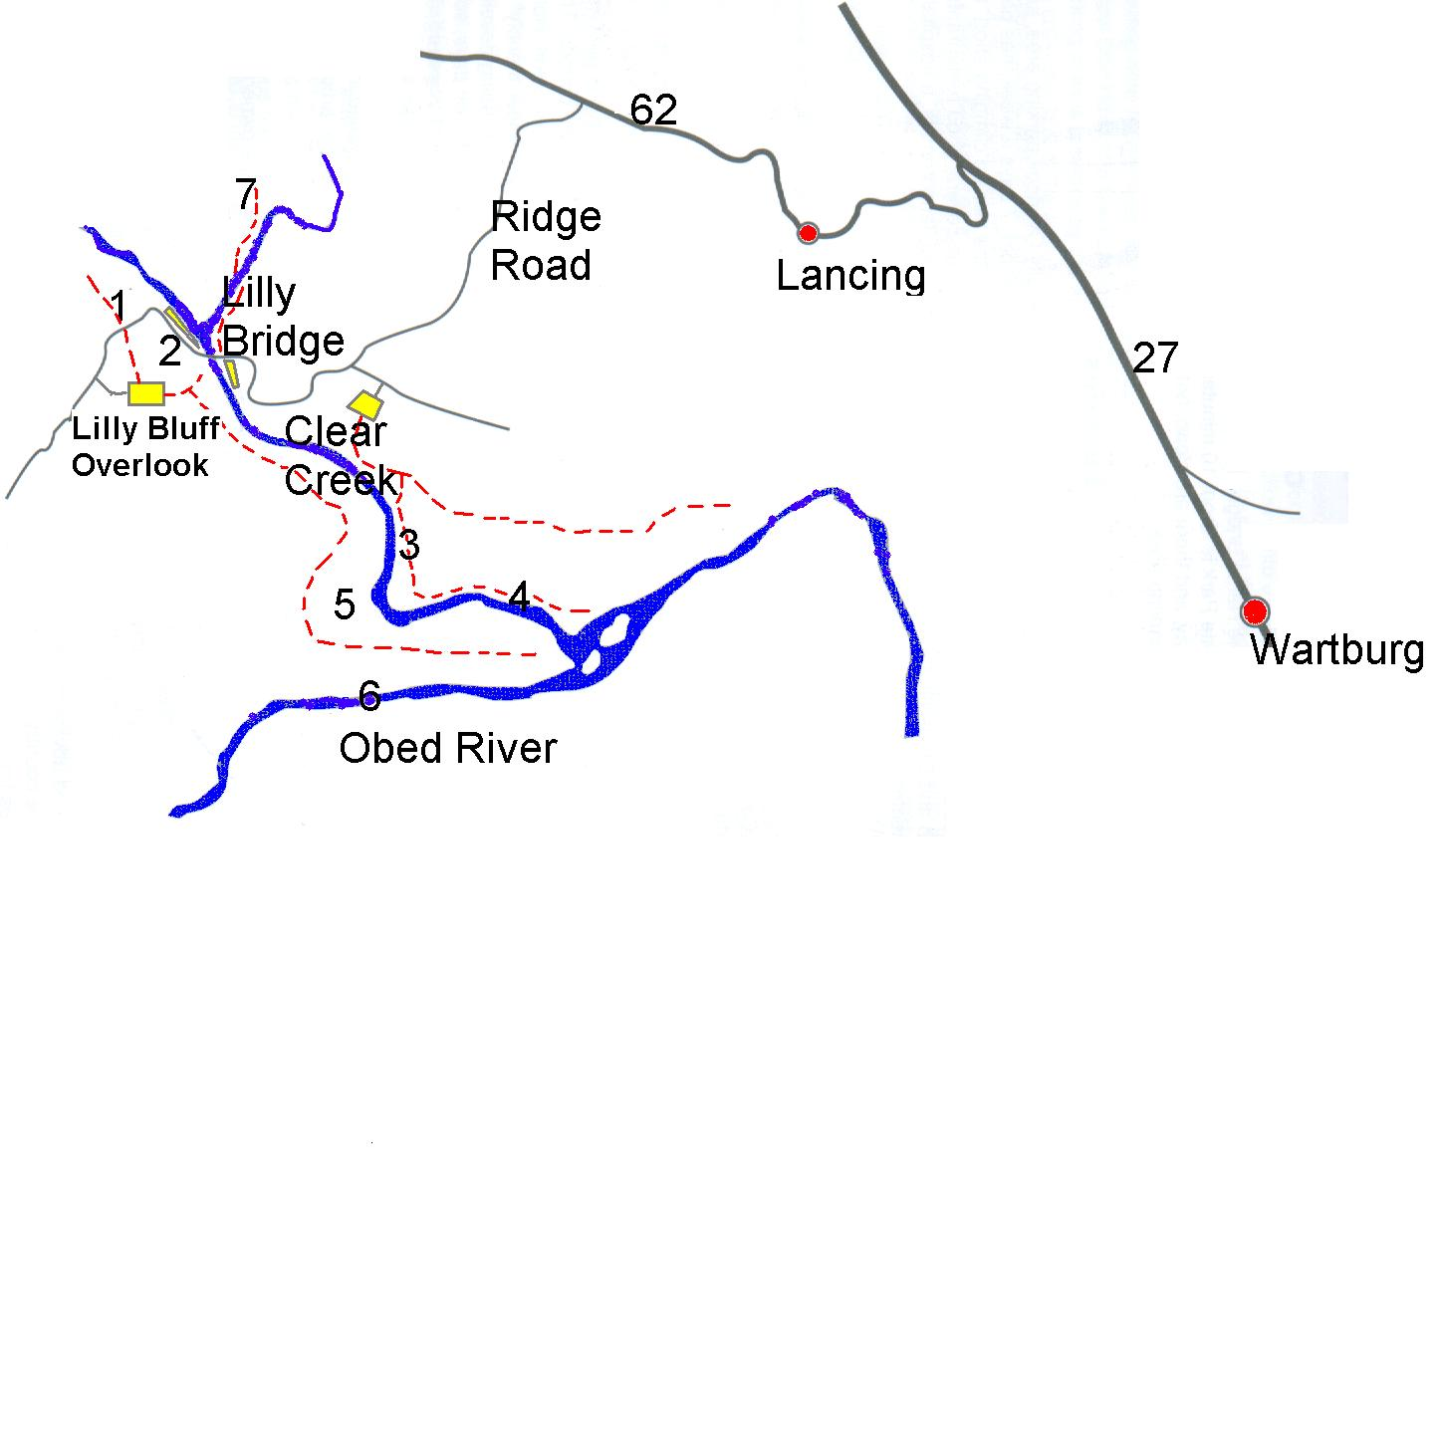

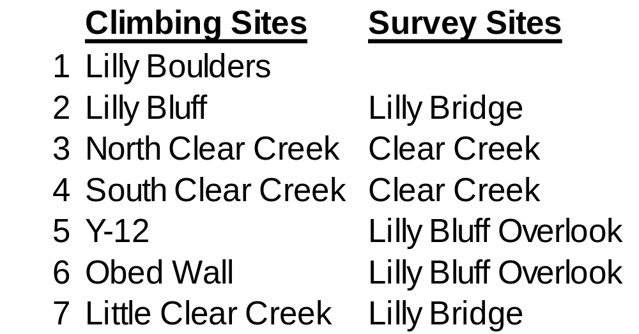

IV. Literature Cited

Caulkins, Peter P., Richard C. Bishop, and Nicolaas W. Bouwes, Sr. 1986. “The Travel
Cost Model for Lake Recreation: A Comparison of Two Methods for Incorporating Site Quality and Substitution Effects.” American Journal of Agricultural Economics. 68(2): 291-297.

Cesario, F. 1976. “Valuing time in recreation benefit studies.” Land Economics 56: 32-41.

Cordell, K., J. Teasley, G. Super, J. Bergstrom, and B McDonald. 1997. Outdoor
Recreation in the United States: Results from the National Survey on Recreation and the Environment. Washington, D.C.: USDA Forest Service.

Desvouges, W. H. and S. M. Waters. 1995. Report on Potential Economic Losses
Associated with Recreation Services in the Upper Clark Fork River Basin. Durham, NC: Triangle Economic Research.

Dillman, Don A. 2000. Mail and Internet Surveys : The Tailored Design Method. John
Wiley & Sons, Inc., New York. 464 p.

Englin, Jeffrey and J. S. Shonkwiler. 1995. “Modeling Recreation Demand in the
Presence of Unobservable Travel Costs: Toward a Travel Price Model.” Journal of Environmental Economics and Management. 29: 368-377.

Fix, Peter and J. B. Loomis. 1997. “The Economic Benefits of Mountain Biking at One
of Its Meccas: An Application of the Travel Cost Method to Mountain Biking in Moab, Utah.” Journal of Leisure Research 29(3): 342-352.

Freeman III, Myrick A. 1999. The Measurement of Environmental and Resource
Values: Theory and Methods. Resources for the Future, Washington, DC.

Grijalva, Therese C., Robert P. Berrens, Alok K. Bohara, Paul M. Jakus, and W.
Douglass Shaw. 2002. “Valuing the loss of rock climbing access in wilderness areas: A national-level random utility model,” Land Economics. 78(1): 103-120.

Haab, Timothy C. and Kenneth E. McConnell. 2002. “Parametric Models for Contingent Valuation” in Valuing Environmental and Natural Resources, 114-36. Cheltenham, UK, Edward Elgar Publishing.

Loomis, J. B. and R. G. Walsh. 1997. Recreation economic decisions: Comparing
benefits and costs (2nd ed.) State College, PA: Venture Publishing, inc.

McConnell, K. and I. Strand. 1981. “Measuring the cost of time in recreation demand
analysis: An application to sportfishing.” American Journal of Agricultural Economics 65: 153-156.

McConnell, Kenneth E. 1986. The Damages to Recreational Activities from PCBs in New Bedford Harbor. Cambridge, Mass.: Industrial Economics.

Morey, Edward R. 1981. “The Demand for Site-Specific Recreational Activities: A Characteristics Approach.” Journal of Environmental Economics and Management 8(4): 345-371.

Morey, Edward R. 1985. “Characteristics, Consumer Surplus, and New Activities: A
proposed ski area. Journal of Public Economics. 26: 221-236.

Randall, A. 1994. “A Difficulty with the Travel Cost Method.” Land Economics 70(Feb.): 88-96.

Rosenthal, D. H., J. B. Loomis, and Peterson G. L. 1984. The travel cost model: Concepts and applications. USDA Forest Service General Technical Report RM-109, 10p. Fort Collins, CO: Rocky Mountain Forest and Range Experiment Station.

Rosenthal, D. H., J. B. Loomis, and Peterson G. L. 1984. The travel cost model: Concepts and applications. USDA Forest Service General Technical Report RM-109, 10p. Fort Collins, CO: Rocky Mountain Forest and Range Experiment Station.

Samples, Karl C. and Richard C. Bishop. 1985. “Estimating the Value of Variations in Anglers’ Success Rates; An Application of the Multiple-Site Travel Cost Method.” Marine Resource Economics 2(1): 55-74.

Shaw, W. D. and P. Jakus. 1996. “Travel cost models of the demand for rock climbing,”
Agricultural and Resource Economics Review 25(2): 133-42.

Shaw, W. D. and M. Ozog. 1999. “Modeling Overnight Trip Choices: Application of
the Repeated Nested Multinomial Logit Model.” Environmental and Resource Economics 13(4) 397-414.

Smith, V. Kerry, William H. Desvouges, and Matthew P. McGivney. 1983a. “Estimating Water Quality Benefits: An Econometric Analysis.” Southern Economic Journal 50(2): 422-437.

United States Department of Agriculture (USDA). 1998. USDA Forest Service Bans
Use of Fixed Anchors for Climbing in Wilderness. Washington, D.C.: USDA Forest Service. News Release (June 1). http://www.fs.fed.us/links/may-dec98.shtml.

U.S. Department of the Interior, National Park Service. 2002. Obed Wild and Scenic
River Draft Climbing Management Plan and Environmental Assessment. 37 pp.

Watford, Chris. 1999. Dixie Cragger’s Atals: A Climbing Guide to Tennessee,
Alabama, and Georgia. Market Place Press, Roswell, GA. 452 p.

Graduate Research Assistant, Department of Forestry, Wildlife, and Fisheries, University of Tennessee-Knoxville. cbsims@utk.edu.
Professor, Department of Forestry, Wildlife, and Fisheries, University of Tennessee-Knoxville, 274 Ellington Plant Sciences, Knoxville, TN, 37996. dhodges2@utk.edu. 865-974-2706.
The grade is based on the respondent’s best climbing and bouldering redpoint achievement. Redpoint is defined as completing a climb without a fall regardless of the number of tries.
The percentages sum to more than 100% because some climbers participate in more than one type of climbing.
This estimate does not include the cost of travel time and depreciated equipment costs.

